Second LACCEI International Latin American and Caribbean Conference for Engineering and Technology (LACCEI’2004)
Times New Roman Font, Size 8 pt, Italic, Single spacing, Left Justify
(This text must be typed by the authors and should appear on the first page only)
“Challenges and Opportunities for Engineering Education, Research and Development”
2-4 June 2004, Miami, Florida, USA

Use of Fly Ash and Municipal Ash in Cost-Effective Structural Concrete for a Sustainable Environment

D. V. Reddy, PhD
Times New Roman Font, Size 10 pt, Bold, Single , spacing, Center

Times New Roman Font, Size 11 pt, Bold, Single spacing, Center

Professor of Civil and Ocean Engineering, Florida Atlantic University, Boca Raton, FL, USA

Times New Roman Font, Size 11 pt, Single spacing, Center

Author Affiliation
Times New Roman Font, Size 11 pt, Single spacing, Center

A. Yemeniciler
Former Graduate Student, Ocean Engineering, Florida Atlantic University, Boca Raton, FL, USA

S. Kastury
Vice President, WRS Infrastructure & Environment, Inc., Tampa, FL, USA

Abstract

Coal fly ash and wood ash, two waste materials, were added singly to concrete mixes as partial replacement of the cement contents. Mechanical property testing and cost analysis were carried out with varying ash incorporation amounts. The objective of the investigation was to determine the changes in mechanical properties and cost-effectiveness of ash modification.

The mechanical tests carried out were as follows: Compressive Strength Tests, Split-Cylinder Tensile Strength Testing, and Slab Testing. The cost analysis comprised the determination of the cost of material for each mix, with different percentages of the ash content.

The test results indicated that MSW bottom ash does not possess the high-strength characteristics found in coal fly ash-modified concrete. The cement altered municipal ash-modified concrete was relatively weak, compared to the coal fly ash-modified concrete. When MSW bottom ash is added as a 10-25% replacement of the total aggregate, the strength values are comparable to those of unmodified concrete. This is a notably important observation because it promotes the utilization of MSW ash in applications where extremely high strengths are not needed.

However, the slab test results show that the strains experienced by the MSW bottom ash-modified pavement are comparable to those that occurred in the coal fly ash-modified slab. The results from the finite element analysis compared well with and validated the experimental data, thus proposing that both fly ash and municipal ash are effective in concrete. This realization suggests that the both ash-modified mixes are reasonable designs for highway pavement applications. Furthermore, by using the ash as opposed to stockpiling it, environmentally sound disposal of the waste can be achieved while providing a cost-effective material to the construction industry.

Keywords
Energy and Cost Saving, Sustainable Environment, Reduction of Global Warming, Cylinder Compressive and Tensile Testing, Slab Finite Element Analysis and Testing

1. Research Significance

The utilization of ash in structural concrete applications contributes to environmentally sound disposal and cost/energy effective use of a waste product. When used as partial replacement (15-50%) of the cement volume, fly ash reduces the amount of cementitious material needed, while contributing to significant improvements in strength and durability of the hardened concrete. Municipal ash may be incorporated in mix designs as a portion of fine and coarse aggregates, thus reducing the large amounts of these natural resources that are normally required by the construction industry. In both cases, ash replacement in small percentages of the entire concrete volume provides the opportunity to preserve natural resources and save millions of dollars in many concrete applications.

2. Introduction

2.1 Coal Ash

The increasing demand for electricity is responsible for the massive consumption and combustion of coal, producing over 80 million tons of fly ash per year in the United States. Generally, there are two physical types of ash that result from the incineration of coal: bottom ash (collected from the bottom of the incinerator) and fly ash (collected from the flues of the incinerator). Accounting for nearly 2/3 of the total annual production of utility wastes, intensive research has promoted many safe, economical and environmentally effective uses for the waste material, which is otherwise stockpiled or disposed of in landfills, (Reddy, 1996). Applications generally employ the flue-collected fly ash due to its fine particulate qualities and the properties discussed in this paper.

When considering utilization for concrete applications, coal fly ash is the best artificial pozzolan. The pozzolanic reaction,

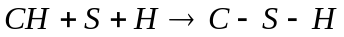 ……(1)

allows the ash to react in water with lime to form low soluble compounds with cementitious qualities. This leads to longer lasting concrete products with low permeability, low heat of hydration, and improved strength and workability.

Considering that the most desirable mode of disposal is utilization, coal fly ash has a very important role in the economy of developing countries. In most of these situations, cement is a very expensive material and is always in short supply. However, coal fired electric power plants provide a steady source of readily available fly ash, which can realistically reduce cement consumption by up to 50%. Therefore, by incorporating this inherent waste product as a material source in the construction industry, a number of environmental and economical benefits can be achieved.

2.2 Municipal Solid Waste (MSW) Ash

The combustion of municipal waste in the modern trash-to-energy facilities is one of the primary components of a fully integrated and environmentally sound approach to solid waste management. There are many extremely valuable energy and cost-effective benefits that arise from trash-to-energy conversion. Primarily, garbage is always in abundance and easily collected. Furthermore, its efficient and safe convertibility to energy makes it a renewable source of fuel and material.

Upon combustion of municipal solid waste (MSW), there are also two types of ash produced. A waste material referred to herein as “MSW bottom ash,” is produced as a secondary bottom-ash waste product along with an airborne residue MSW fly ash. Both products can be safely managed in a number of ways. Like coal fly ash, MSW bottom ash may be utilized as a partial replacement material in concrete. However, due to the heterogeneous origin, the ash resulting from mass-burned municipal waste does not meet the chemical requirements for either Class C or Class F pozzolans, (Hamernik and Frantz, 1991). Therefore, it is more effective to add the ash as a part of total aggregate rather than cement.

Proportions of 10-25% ash replacement significantly reduce the necessary amounts of coarse and fine aggregates. In major construction jobs that require massive amounts of concrete, such as the highway infrastructure, small percentages can contribute to savings of many tons of coarse and fine aggregates.

3. Properties

3.1 Physical Properties

The primary comparison of ash materials is based on the physical characteristics. With reference to concrete applications, these include physical appearance, particle size and shape, microstructure, moisture content, and water requirements of the mix. Although MSW bottom ash and coal fly ash derive from similar incineration processes, their physical properties vary quite extensively. The shape, fineness, particle-size distribution and density greatly affect the properties of the resulting concrete.

Generally, fly ash is divided into two classes. Class C ash is derived from sub-bituminous and lignite coals, whereas Class F ash comes from bituminous and anthracite coal sources. Furthermore, fly ash produced at different power plants, or with different coal sources, tends to vary in color from tan to light gray or black. In contradistinction, MSW bottom ash tends to be very black in color and possesses a texture similar to topsoil. In addition, municipal ash that has been collected from the bottom of the incinerator often contains small pieces of melted glass and particulates. Besides the indication of a variation and lack of homogeneity of sources, chemical contents, or burning conditions, different colored ashes can influence the final color of the hardened concrete.

Fly ash collected from the flues of coal-fired incinerators possesses extremely fine particulate qualities similar to unmixed cement, which is an advantage when it is used for partial replacement in a mix. The smooth surfaced spherical particles aid in the production of a cementitious material when combined with activators such as lime, cement or kiln dust. The typical electron microscope image shown in Figure 1(a) depicts the spherical microstructure of coal derived fly ash magnified 1000x. For comparison, Figure 1(b) shows the 1000x magnified image of a MSW ash. Bottom ash samples have greater surface areas and show the existence of a variety of shapes and surface textures, such as “shredded sponge,” “rolled paper,” and “corral,” (Hamernik and Frantz, 1991).

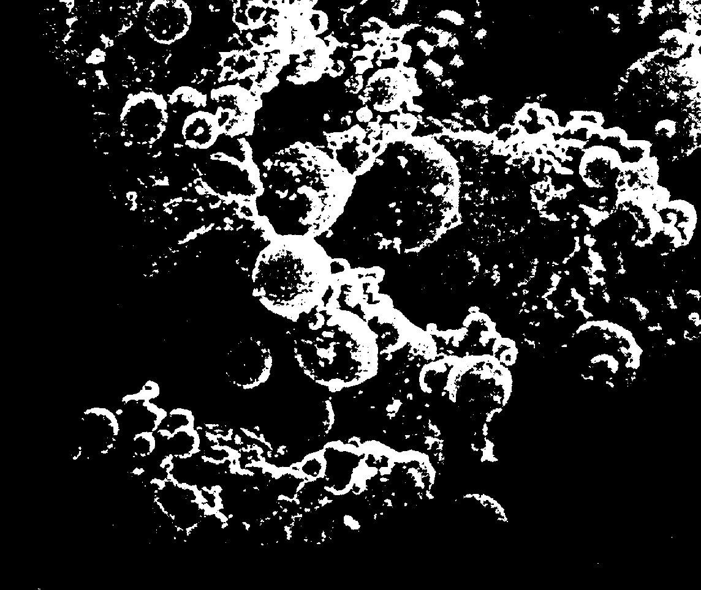  (a) Coal fly ash | 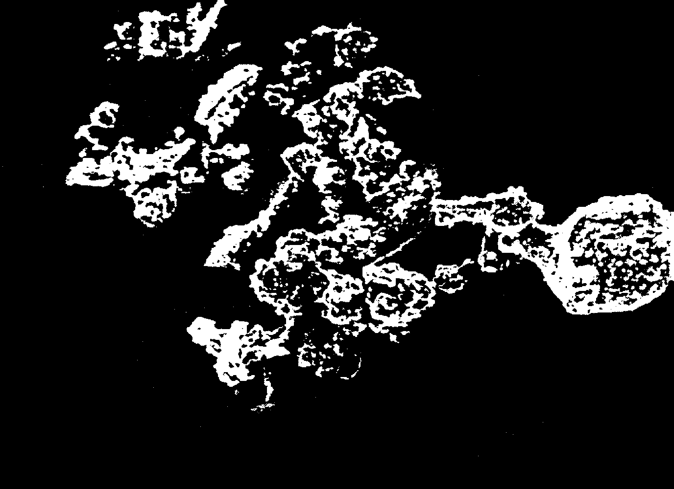  (b) MSW bottom ash

Fig.1 Scanning Electron Microscope (SEM) images of the microstructures magnified 1000x (Reproduced from Hamernik and Frantz, 1991).

Normally, coal is highly pulverized before firing and subsequently burned at temperatures near 1500ºC, resulting in a homogeneous material that fuses and condenses into the cenospheres found in the resulting fly ash. In contrast, municipal waste is highly heterogeneous and not pulverized prior to incineration at 1000ºC. Therefore, the resulting bottom ash lacks a clearly defined matrix and the spherical attributes of coal fly ash. These variations in the microstructure of MSW bottom ash are part of the properties that detract from the cementitious qualities of municipal ash-modified concrete.

Furthermore, the relatively large surface areas associated with MSW bottom ash contribute to the tendency for this material to absorb moisture from the atmosphere. It has been shown by Hamernik and Frantz (1991) that with sufficient time, MSW ash has the ability to absorb 20% moisture from the surrounding air. Coal derived fly ash, on the other hand, does not absorb any moisture from the atmosphere. These are very important aspects because they indicate how each ash will affect the water/binder (w/b) ratio needed for proper mix design. Coal fly ash does not require any increase in water; in fact, it can provide equal or better performance with a lower w/b ratio. However, due to the natural affinity to water of MSW derived ash, any applications of municipal ash-modified concrete must provide an increase in w/b ratio to cope with the problem of hydration.

3.2 Chemical Properties

Whenever using ash modifications in concrete applications, it is imperative to understand how these admixtures will react with and affect the surrounding environment. The benefits for coal fly ash generally include the reduction of heat generated by hydration, and the reactions with the products of hydration; and the increased resistance to permeation. However, municipal waste sources necessitate the need for chemical investigations of the leaching abilities of various toxic compounds and heavy metals that may exist in the ash, as well as their effects on the cementing process.

The chemical aspects of coal fly ash greatly improve the properties of hardened and fresh concrete. When Portland cement reacts to form concrete, there tends to be an early rise in temperature that presents a major problem when pouring massive structures. However, the ash has the ability to reduce the high heat of hydration normally associated with the cementing process by slowing the rate of reaction. By achieving a slowed reaction rate, there is less heat generated in the early stages of cementing and the result is more structurally durable concrete.

Upon mixing, solutions of calcium and alkali-hydroxide are released into the pore structure of the paste, and combine with the pozzolanic particles of the coal derived fly ash to form a cementing medium, (Reddy 1996). Combined with ordinary portland cement, the resulting paste is highly cementitious and workable. Furthermore, the reaction products have the ability to fill the pore spaces between the cement particles reducing the permeability of the hardened concrete. The advantage of reduced permeability is the protection of the embedded steel rebar by inhibiting the infiltration of aggressive corrosion promoters, such as chlorides and carbon dioxide. In the marine environment, where cracking and spalling occur due to internal corrosion, this chemical property strongly supports the utilization of coal fly ash-modified concrete.

Unfortunately, the chemical properties of municipal bottom ash are not as advantageous as coal fly ash. The only MSW ash that showed signs of pozzolanic activity (similar to Class C fly ash) was that collected from refuse-derived fuel, which requires removal of all ferrous material, glass, and shreds of the remaining solids prior to burning, (Hamernik and Frantz 1991). However, municipal ash from the as-received condition does not meet the requirements of a pozzolanic classification and therefore, does not react with portland cement in a cementitious fashion. Furthermore, according to (Hamernik and Frantz 1991), MSW ash does not exhibit cementitious properties and does not set when mixed with only water. This is the reason for adding MSW bottom ash to the mix design as a fraction of total aggregate, while holding the cement content constant. Without the pozzolanic reaction, there is no reduced permeability and no reduced heat of hydration. In fact, due to the increased particle surface areas previously discussed, municipal ash-modified concrete demands a significant increase in the w/b ratio of the mix design to cope with hydration.

The major problem with incorporating MSW bottom ash in mix design is the leaching capabilities of the inherent organic compounds and heavy metals that may be present in the resulting concrete. Of particular and obvious concern are the cadmium and lead levels that are significantly higher than the toxicity limits of the Toxicity Characteristic Rule published in the Federal Register. However, Wheelabrator Environmental Systems Inc. has developed a technology that effectively immobilizes the leaching capabilities of these and other toxic metals found in municipal ash through dissolution and precipitation reactions, (Lyons, 1995). This process is known commercially as the WES-PHix® Ash Stabilization Process and guarantees that the chemical contaminant contents of the treated ash are below the federal limits through a test termed the Toxicity Characteristic Leaching Procedure (TCLP), thereby providing safe and environmentally sound ash for utilization in concrete applications. The results of this test for lead and cadmium are listed in Table 1.

Table 1 TCLP Results for Untreated vs. WES-PHix® Treated Ash (mg/L) (Sources: Lyons and Toxicity Characteristic Rule)

Metal | Federal Limit | Untreated Raw Ash | Treated Wes-Phix® Ash
Lead | 5.0 | 6.20 | 0.276
Cadmium | 1.0 | 1.30 | 0.078

Clearly, the WES-PHix® process effectively reduces the levels of toxic materials to well below the federal limits. Therefore, the treated ash is a realistically safe and viable material for utilization in environmental applications.

4. Applications

The applicability of different fly ash mixes is linked to the level of concrete technology required for the concerned structural components. The applications can be divided into three categories: Low Technology (less than 20 MPa), Medium Technology (20-50 MPa) and High Technology (greater that 50 MPa). It is to be pointed out that MSW bottom ash is excluded from High Technology applications due to the relative lack in strength. The following is a list of some examples of these applications:

4.1 Low Technology Applications (< 20 MPa)

a) Pavement base and sub-base courses:
Fly ash is combined with lime or portland cement and aggregate and the pozzolanic reaction of fly ash results in an increase in strength with time.
b) Subgrade stabilization:
Fly ash, in combination with lime, is used to reduce plasticity and increase strength.

4.2 Medium Technology Applications (20-50 MPa)

a) Ash-modified ready-mixed concrete:
Many concrete producers use fly ash to overcome deficiencies in aggregate grading or have developed mixtures specifically for pumping. This takes advantage of the capacity of concrete containing fly ash to pump higher and further at faster rates, and with less segregation. MSW bottom ash may be used in this application to reduce the amounts of aggregates that are normally included. Fly ash is increasingly being used for the following reasons:
- Technical benefits
- Reduced cement requirement with partial replacement of fly ash
- Promotes high technology applications of fly ash-modified concrete
- Increasing availability of fly ash meeting industry needs
b) Concrete pavements:
Fly ash reduces map cracking and abnormal expansion and many states have conducted experiments on fly ash-modified concrete to evaluate the strength, crack resistance, finishing, and long term wear resistance. MSW bottom ash reduces the amount of coarse and fine aggregates used in pavement applications.

c) Mass concrete:
The use of fly ash can reduce thermal stresses by providing a reduction in the large heat of hydration generated in the mixing process for massive concrete structures. Fly ash effectively reduces the temperature rise (relieving thermal stresses) of these massive structures and MSW bottom ash can reduce the sizable amounts of aggregates normally required.

d) Concrete masonry units:
Using fly ash in concrete mixtures improves the finish, the texture, and enables sharper corners. Most importantly, it provides added plasticity to the relative harsh mixtures associated with molding process of concrete masonry units.

e) Concrete pipes:
Pipes containing fly ash are more resistant to weak acid and sulfates due to decreased permeability of the modified concrete. Furthermore, there is an increase in cohesiveness and a reduction of hairline cracks.

f) Precast/Prestressed products:
Due to improved workability, products precast with fly ash provide sharp distinctive corners and edges and result with a better surface appearance. Applications of this nature are particularly desirable for products with intricate shapes or heavy reinforcement.

g) Hollow-core slabs:
Use of fly ash increases the workability of the harsh mixes associated with the “no-slump” conditions required by pre-tensioned hollow-core slabs.

h) Bricks, blocks and paving stones:
Both fired and unfired, bricks can be made with fly ash and bottom ash. The coal research bureau of West Virginia University has developed a method for molding and firing bricks from a mixture of 72% fly ash, 25% bottom ash, and 3% sodium silicate, (Naik et al., 1992).

4.3 High Technology Applications (> 50 MPa)

- Bridge decks and substructures
- Offshore and coastal structures
- High rise buildings
- Shell structures

4.4 Other Applications

a) Grouts and mortars:
The benefits of using fly ash and MSW bottom ash in these applications are the same as those achieved upon utilization in concrete.

b) Controlled low strength materials (CLSMs):
CLSMs are made up of cement ash, fine aggregate and water. They are ideal for backfilling, pipe bedding and protection, foundation sub-bases, spread footings, paving bases, floor files, culverts, steamlines and sewer lines.

c) Soil cement:
Soil cement is used as a base for road, street, and airport paving. Other uses include slope protection for dams and embankments, and liners for reservoirs. Both coal fly ash and MSW bottom ash can be utilized in these applications.

The authors have been actively involved in evaluating and comparing the influence of ash substitution of cement and aggregates on the mechanical properties (compression, tension, bending) of hardened and fresh concrete. Typical results from an experiment comparing coal fly ash and MSW bottom ash are presented in the following sections.

4.5 Mix Design

The test specimens were 39 in total and covered a wide variety of comparative mix designs that are represented in Tables 2-5. The control specimens (9 total) were comprised of an unmodified classical-type mix represented by Mix A. There were also nine specimens of Mix B containing varying proportions of coal fly ash. In order to provide a direct comparison between the behaviors of different ash modifications, Mix C was designed to exactly replicate Mix B, except that MSW bottom ash was substituted for the coal fly ash proportions. It is important to note that both of these mixes (B and C) were used to test the effect of reducing cement content with ash replacement while everything else is held constant. However, due to the lack of cementitious qualities that was expected of MSW bottom ash, twelve specimens of Mix D was used to test the concept of holding the cement content constant and replacing part of the aggregate (sand and pearock).

Table 2 Mix A: Control (Unmodified)

Mix Number | Cement  (N/m³) | Ash  (N/m³) | Water  (N/m³) | Sand  (N/m³) | Pearock  (N/m³) | W/B Ratio
A – 1 | 2386.2 | N/A | 1134.9 | 8200.4 | 10022 | 0.33

Table 3 Mix B: Fly Ash – Modified

(Partial replacement of cement)

Mix Number | Cement (N/m³) | Ash (N/m³) | Water (N/m³) | Sand (N/m³) | Pearock (N/m³) | W/B Ratio
B – 1 | 2386.2 | 1024.3 | 1134.9 | 8200.4 | 10022 | 0.33
B – 2 | 2217.4 | 1193.1 | 1134.9 | 8200.4 | 10022 | 0.33
B – 3 | 2048.6 | 1367.7 | 1134.9 | 8200.4 | 10022 | 0.33

Table 4 Mix C: Municipal Ash – Modified

(Partial replacement of cement - – Replicate of Mix B))

Mix Number | Cement (N/m³) | Ash (N/m³) | Water (N/m³) | Sand (N/m³) | Pearock (N/m³) | W/B Ratio
C – 1 | 2386.2 | 1024.3 | 1134.9 | 8200.4 | 10022 | 0.33
C – 2 | 2217.4 | 1193.1 | 1134.9 | 8200.4 | 10022 | 0.33
C – 3 | 2048.6 | 1367.7 | 1134.9 | 8200.4 | 10022 | 0.33

Table 5 Mix D: Municipal Ash – Modified

(Partial replacement of aggregate)

Mix Number | Cement (N/m³) | Ash (N/m³) | Water (N/m³) | Sand (N/m³) | Pearock (N/m³) | W/B Ratio
D – 1 | 3026.4 | 1164 | 1210.6 | 7618.4 | 9440 | 0.40*
D – 2 | 2910.0 | 2328 | 1455.0 | 7036.4 | 8858 | 0.50*
D – 3 | 2619.0 | 4656 | 1571.4 | 5872.4 | 7694 | 0.60*
D – 4 | 2619.0 | 5820 | 1833.3 | 5290.4 | 7112 | 0.70*
* W/B Ratio increases for municipal ash mixes to cope with the problem of hydration.

4.6 Compressive Strength Tests

Compressive load tests of 4x8 inch cylindrical specimens was performed for all mixes in accordance with ASTM C469, the standard for uni-axial compression testing. The compressive strength (C) was then computed from the following formula and the results were included as Figures 2(a)-(c):

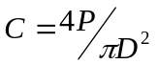 ………(2)

where, P is the ultimate axial load and D is the diameter of the specimen.

4.7 Split-Cylinder Tensile Strength Testing

Based on the results of the compressive strength tests, the most efficient mixes from categories A, B and D were identified and then tested in tension (Mix C was omitted due to extremely poor compression results). The tensile strength of the chosen mixes was determined by way of indirect compression whereby a cylindrical specimen is loaded diametrically until fracture by lateral split is experienced. The test was performed according to ASTM C496, the standard for splitting tensile strength tests. The tensile strength (T) of each specimen was then calculated from the following formula and the results are represented by Figure 3:

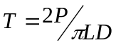 ………(3)

where, P is the ultimate diametrical load, and L and D are the length and diameter of the cylindrical specimen, respectively.

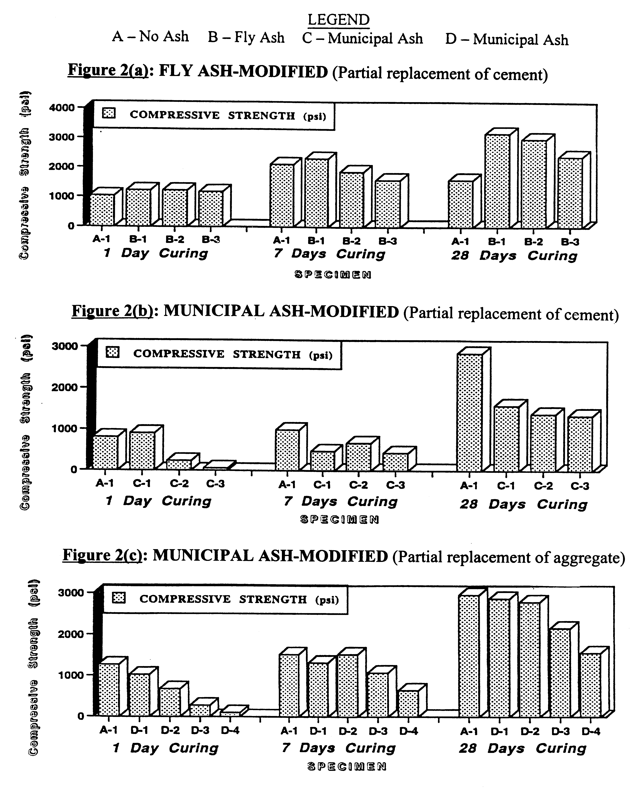

Fig.2 Partial replacement of cement and aggregate

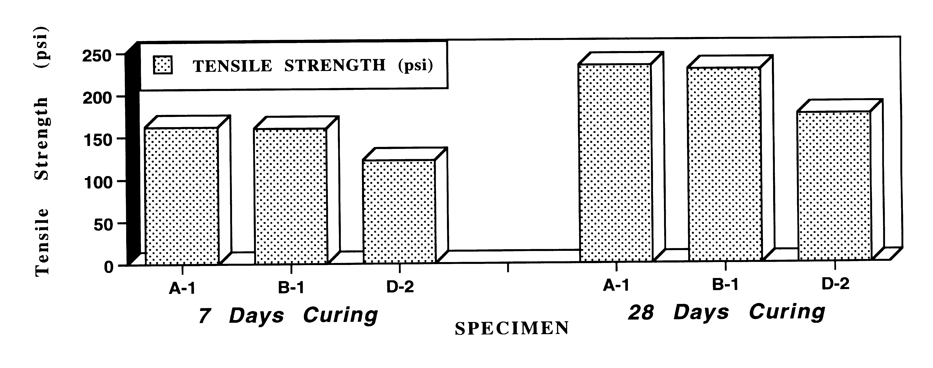

Fig.3 Tensile strength comparison of three mixes

4.8 Slab Testing

Completing the experimental research of this project involved flexural testing of conceptual highway pavements with ash modifications. As in the split-cylinder experiments, the specimens are comprised of three specific mixes providing a comparison between unmodified, coal ash-modified, and MSW bottom ash-modified concretes: A-1, B-1, and D-2. However, based on the concept of simulating an infinite slab on an elastic foundation with a slab of finite dimensions, these specimens were determined to be 4 ft square slabs with no reinforcement. Primarily, the highway infrastructure can be modeled as a uniform slab that extends to infinity in both directions and upon a point loading at the center, the two directional strains can be measured. A schematic of the experimental test setup and the actual test setup are shown as Figures 4(a) and (b), respectively.

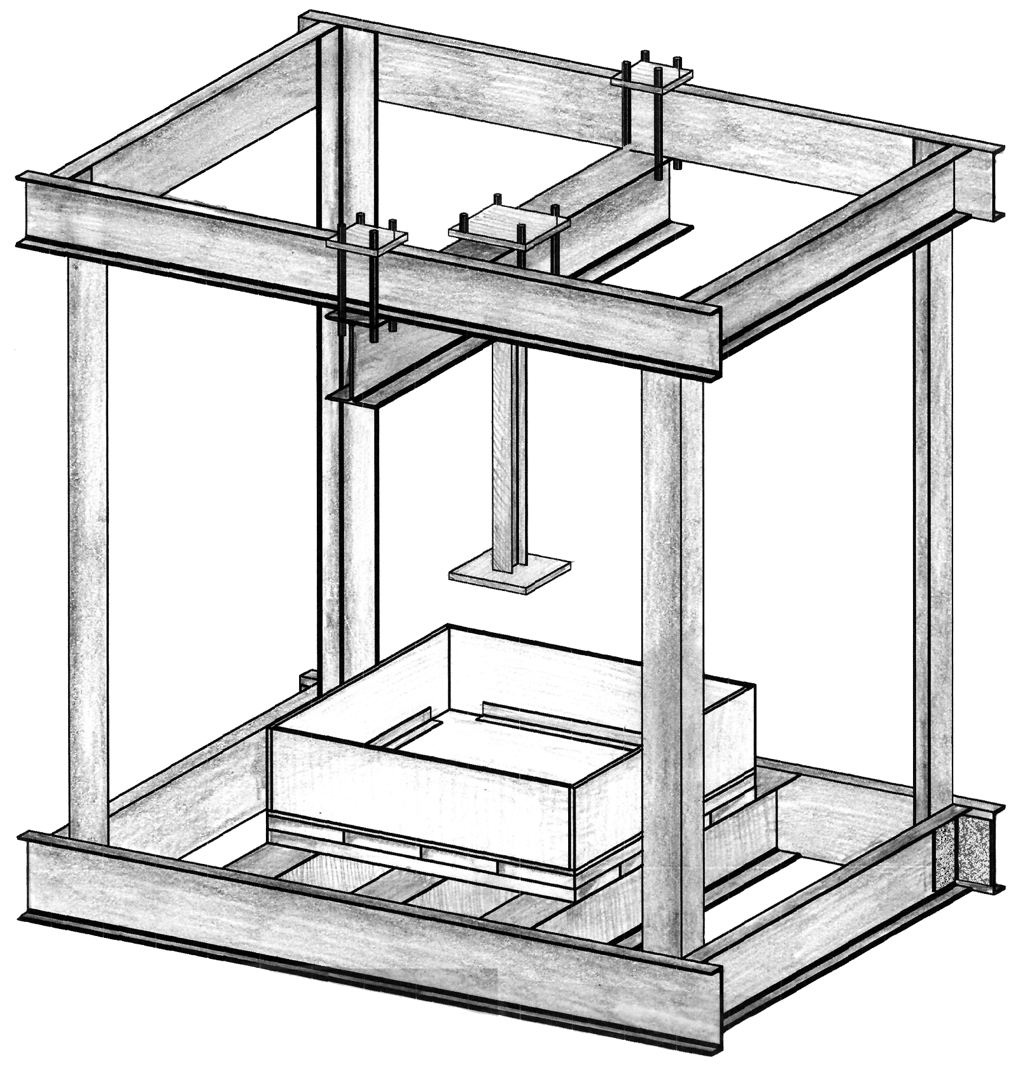  (a) Schematic | 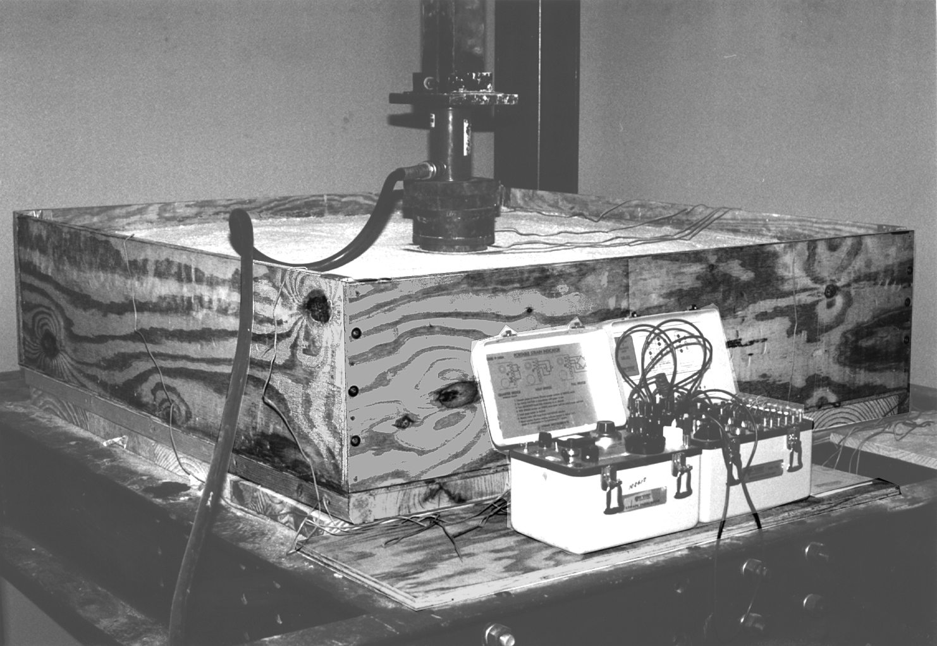  (b) Actual

Fig.4 Experimental Slab Test Setup

Slab testing for all three mixes (A-1, B-1 and D-2) was completed and the and the resulting load vs. strain values are graphed in Figures 5(a), (b) and (c).
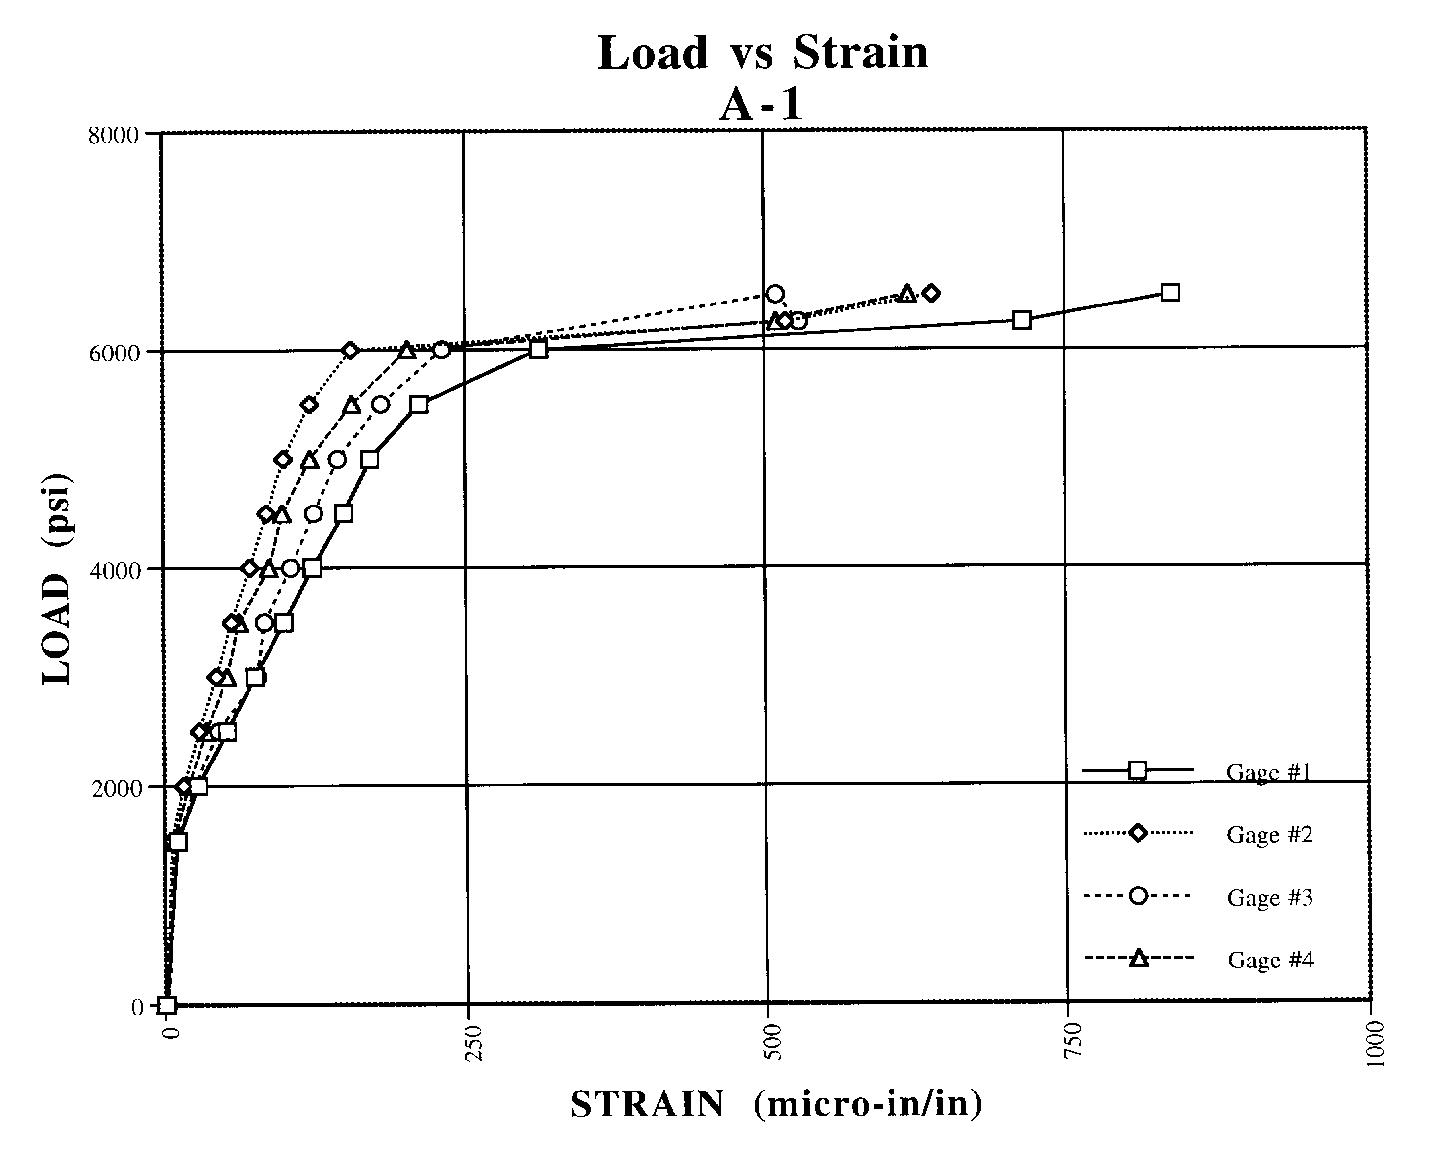

Fig.5 (a) Load vs. Strain plots for unmodified 4 ft² concrete slabs

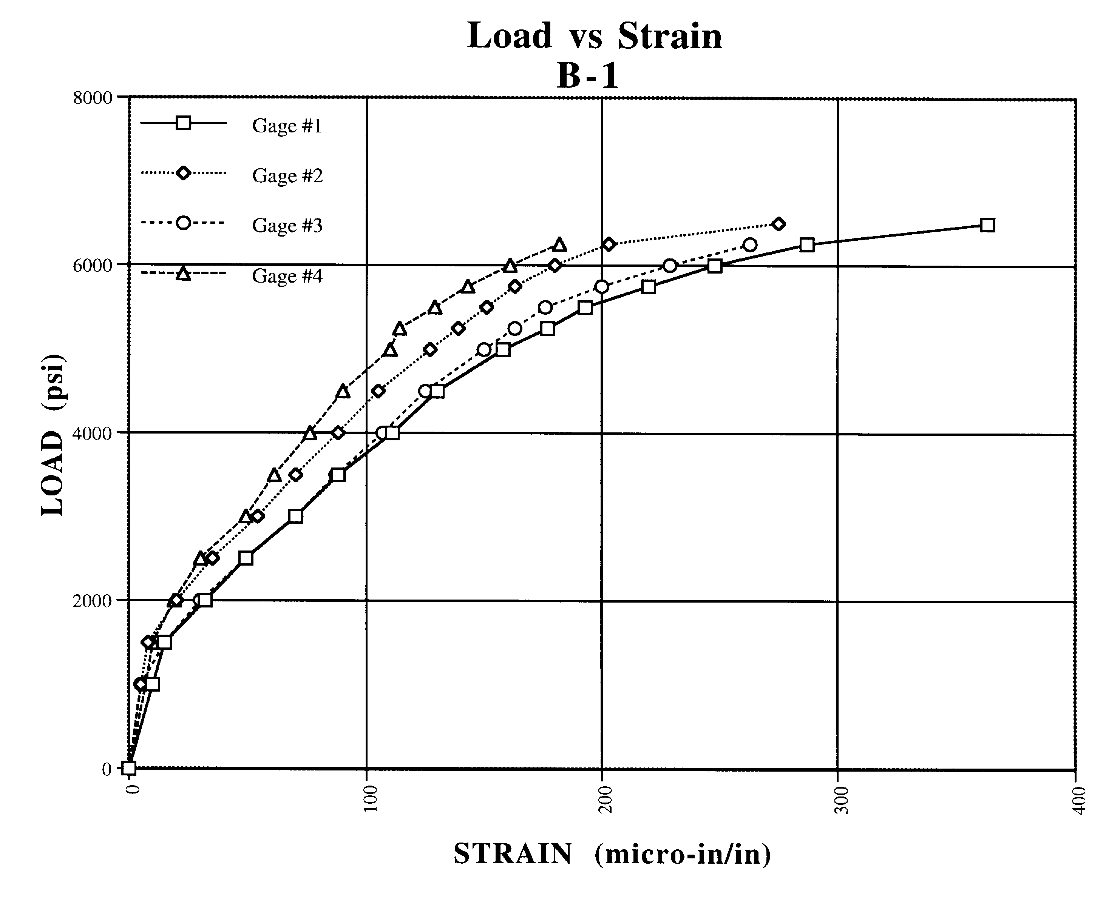

Fig.5 (b) Load vs. Strain plots for coal fly ash-modified 4 ft² concrete slabs

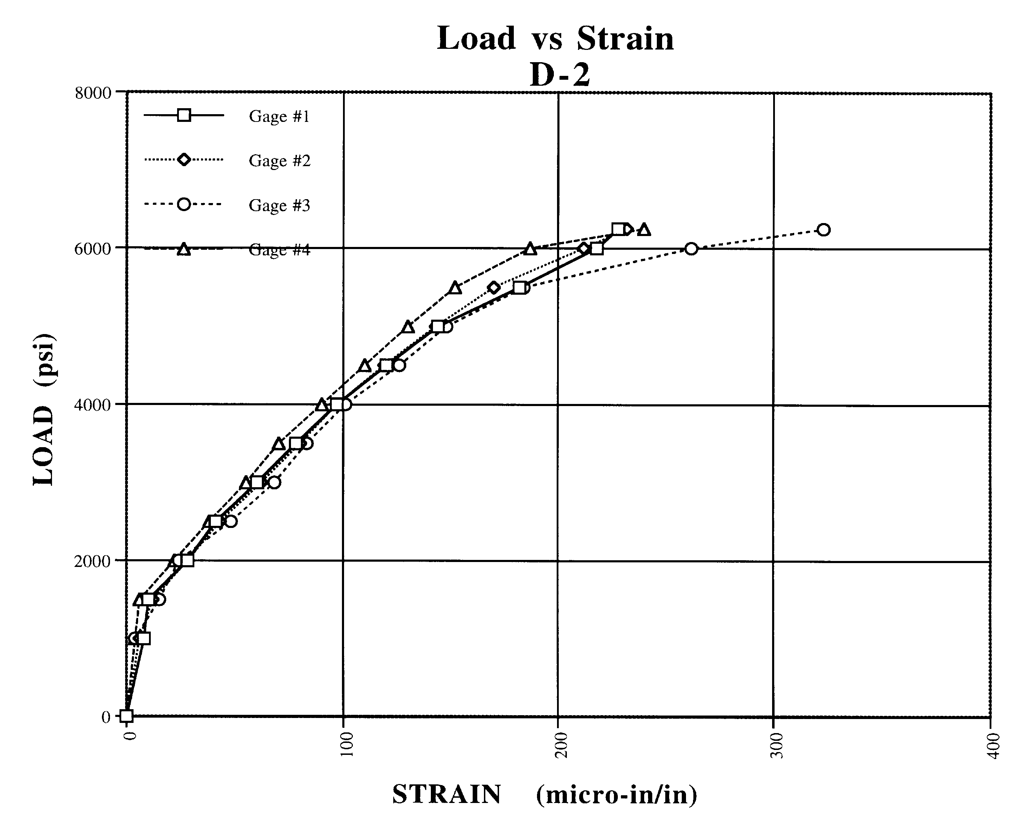

Fig.5 (c) Load vs. Strain plots for MSW bottom ash-modified 4 ft² concrete slabs

4.9 Finite Element Analysis

4.9.1 Formulation

The mixes which were tested experimentally as slabs (unmodified, fly ash-modified, and municipal ash-modified), were modeled for finite element analysis. The slab was idealized as a mesh of small square elements connected at the corners (nodes), with the soil as an elastic foundation of individual springs located at each node. Known as a Winker foundation, it is an elastic isotropic half-space as shown in Figure 6.

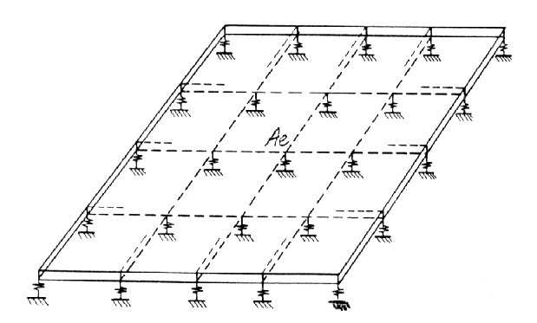

Fig.6 Finite element slab on elastic foundation

At each node, three degrees of freedom were defined as a vertical deflection, a rotation about the x-axis, and a rotation about the y-axis. An external load can act in the direction of each of the above deformations in Figure 6. The internal stress resultants (moments and shears) are related to the degrees of freedom of an element by a stress matrix derived for the finite element as shown below in Figure 7. The stiffness matrix of the plate is assembled by joining the stiffnesses of the elements adjacent to each node:

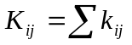 …..……(4)

where, k_{ij} = stiffness matrix of the element, and K_{ij} = stiffness matrix of the slab.

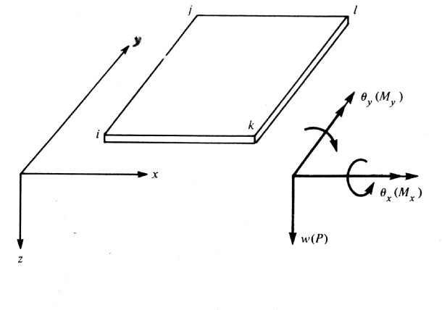

Fig.7 Forces and corresponding displacements

The soil is represented by springs at element nodal points to resist the slab load and simulate the elastic foundation. The spring constant was determined from subgrade properties based on specifications of the Florida Department of Transportation. The matrix given by:

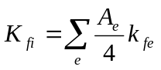 …..……(5)

where, K_{fi} = soil stiffness at node i, A_{e} = area of element surrounding the node i, and k_{fe} = coefficient of subgrade reaction for the element under consideration.

The structural system is defined as the foundation slab and the soil and the equilibrium of the system is expressed by the following matrix equation:

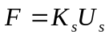 …..……(6)

where, F = external loading, K_{s} = stiffness matrix of the structural system, and U_{s} = nodal deformation vector.

The contact pressure at a particular node is given by:

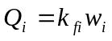 …..……(7)

where, Q_{i} = contact pressure at node i, k_{fi} = coefficient of subgrade reaction, and w_{i} = deflection at node i.

4.9.2 Input and output parameters

PRO-STAAD was the software used as a pre and post-processor for STAAD III, which was utilized for definition of the grid and also for the preparation of the data file for input to the finite element and stress analyses. STAAD, an interactive graphical software, formulates the mesh representing the cross-section with the required degrees of precision. The properties of the cross-section, such as the mechanical properties of concrete, were introduced into the model with 81 nodal points and 64 elements, shown in Figure 8.

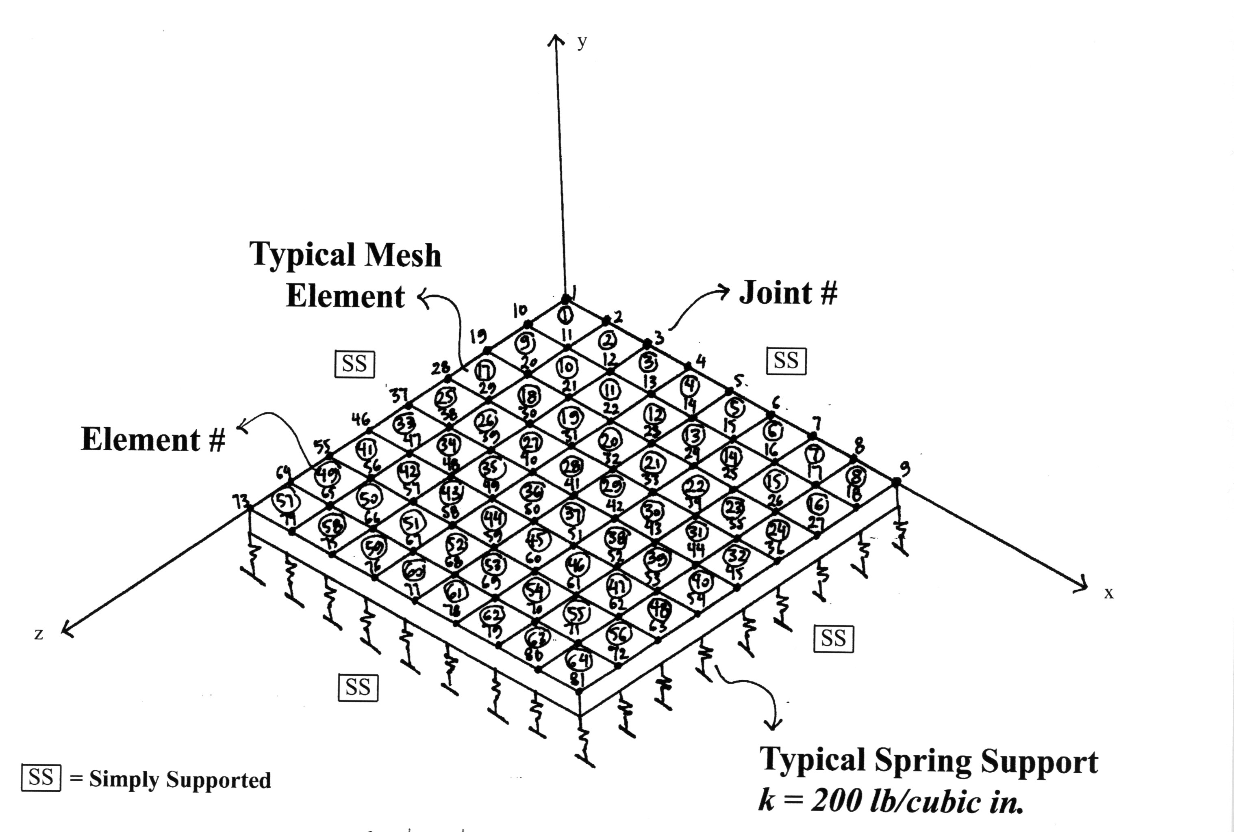

Fig. 8 STAAD III, Finite element model

Each nodal point was supported by spring constants and for each different type of ash, the modulus of elasticity changed based on the strength tests (E = 57,000f_{c}^{½}). Spring constants were used to model the grade, where the coefficient depended on the soil type (sand compacted to 200 lb/in³, i.e. 0.049 N/mm³ ) and was chosen according to the Florida Department of Transportation Manual (FDOT, 1992). Furthermore, the thickness of the slabs was determined based on the common FDOT field practice. The computer analysis was controlled to limit the number of iterations and cycles in order to optimize speed and maximize accuracy.

The program output begins by listing all of the various options selected as inputs in the finite element process. The input file follows with the respective label attached to all the parameters for ease of debugging and deciphering. The main output includes a complete listing of the deflections and rotations (in radians) at each nodal point reported at the end of each increment, and the maximum nodal deflection change for that increment. The output for each element contains shear forces, moments, stresses, and with the element numbers for top and bottom of the slab.

4.9.3 Finite element results

The finite element modeling parameters were based on the input from the compressive testing and the modulus of elasticity for each mix. The load application was kept the same for each model but the properties were changed according to the mix. The load deflection relationships at the center of the slab are presented in Figures 9(a)-(c).

The lack of smoothness in the analytical curve is due to approximations associated with averaging of the deflection in the individual elements. Stresses are also shown for each mix, with the higher stresses induced close to the center of the slab where the point load was applied. Municipal ash-modified concrete (Mix D-2) exhibited higher stresses when compared to the other cases, but overall results indicated that both fly ash and municipal ash may be effectively utilized in the concrete applications of the highway infrastructure.

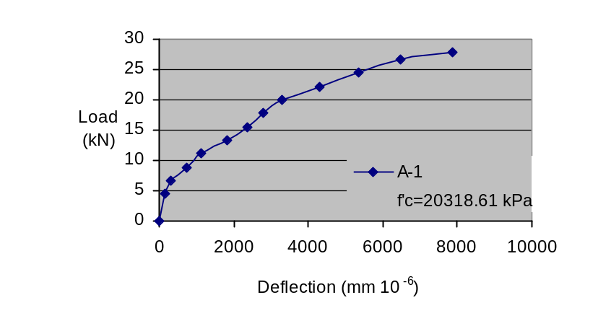

(a) Finite element results for an unmodified concrete slab-on-grade (A-1) at 28 day strength

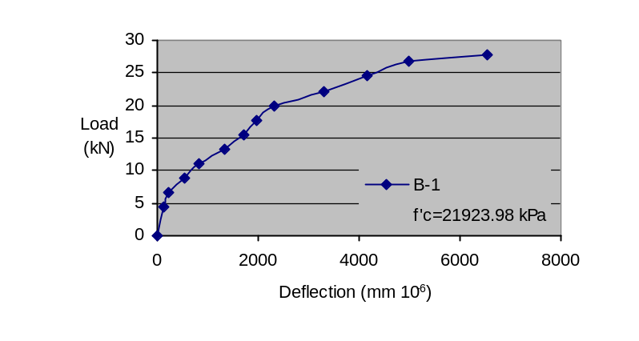

(b) Finite element results for a fly ash-modified concrete slab on-grade (B-2) at 28 day strength

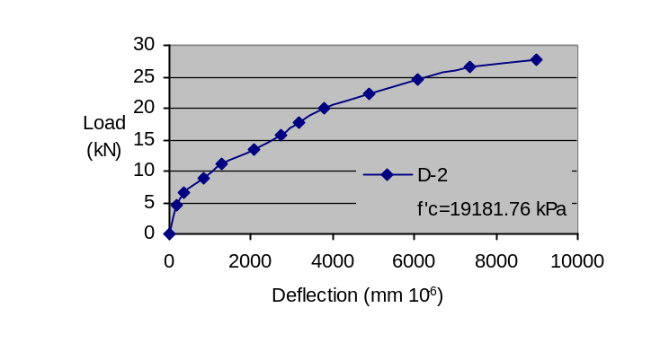

(c) Finite element results for a municipal ash-modified concrete slab-on-grade (D-2) at 28 day strength

Fig.9 Finite element results

5. Discussion

The test results indicated that MSW bottom ash does not possess the high-strength characteristics found in coal fly ash-modified concrete. The cement altered municipal ash-modified concrete (Mix C) was relatively weak, compared to the coal fly ash-modified concrete (Mix B). However, Figure 2(c) shows that when MSW bottom ash is added as a 10-25% replacement of the total aggregate (Mix D), the strength values are comparable to those of unmodified concrete (Mix A). This is a notably important observation because it promotes the utilization of MSW ash in applications where extremely high strengths are not needed.

However, the slab test results depicted in Figure 5 show that the strains experienced by the MSW bottom ash-modified pavement are comparable to those that occurred in the coal fly ash-modified slab. The results from the finite element analysis compared well with and validated the experimental data, thus proposing that both fly ash and municipal ash are effective in concrete. This realization suggests that the both ash-modified mixes are reasonable designs for highway pavement applications. Furthermore, by using the ash as opposed to stockpiling it, environmentally sound disposal of the waste can be achieved while providing a cost-effective material to the construction industry.

6. Conclusions

In conclusion, it is clear that ash utilization, as a substitute to natural resources in the construction industry is an energy efficient and environmentally safe alternative to the disposal of a waste product. Coal fly ash is highly acceptable for a wide range of applications from the high strength needs of highway infrastructure to the corrosive elements of the marine environment. MSW bottom ash is inherently restricted to lower strength applications, but still may be utilized in a number of ways. By utilizing these waste materials, the construction industry can not only reduce costs, but also contribute to the effective disposal of a large volume waste product and save valuable natural resources.

7. Acknowledgments

The author would like to thank Dr. L. Berry, Distinguished Professor and Director, Center for Environmental Studies, Florida Atlantic University for funding the work described within this paper. The active participation and technical assistance provided by Mr. S. Kastury, Vice President, WRS Infrastructure and Environment, Inc., and Mr. A. Yemeniciler and T. Pierro, former graduate students are gratefully acknowledged. Gratitude is expressed to Duos Engineering, Jacksonville, FL, for gifting the MSW bottom ash and technical advice that supported the project in a significant manner. Also, thanks are due to Dr. S. E. Dunn, Distinguished Professor and Former Chairman, Department of Ocean Engineering, and Dr. S. Nix, Professor and Chairman, Department of Civil Engineering, FAU, for their support and encouragement.

8. References

ACI Committee 232, (1996). “Use of Fly Ash in Concrete,” ACI 232.3R-96, Farmington Hills, MI, April, pp.21-26.
Federal Register, (1990). “Toxicity Characteristic Rule,” 40CFR 261.24.
Hamernik, J.D. and Frantz, G.C., (1991). “Physical and Chemical Properties of Municipal Solid Waste Fly Ash,” ACI Materials Journal, V. 88, No. 3, May-June, pp. 294-301.
Lyons, M.R., (1995). The WES-PHix® Ash Stabilization Process, Wheelabrator Environmental Systems Inc., Hampton, New Hampshire.
Naik, T.R., Singh, S.S., and Patel, V.M. (1992). “State of the Art: Fly Ash, Silica Fume and Slag Utilization in USA,” Report No. REP-150, Univ. of Wisconsin, Milwaukee.
Reddy, D.V. (1996). “Use of Fly Ash in the Transportation and Building Infrastructure,” Workshop at Florida Atlantic University, Boca Raton, September, pp. 1-7.
Second Level Heading
Times New Roman Font, Size 11 pt, Title Case, Bold

Third Level Heading
Times New Roman Font, Size 11 pt, First Letter Capital, Bold

Company or University, Country, Academic Qualification, (Times Roman Font, Size 10pt)

9. Notations

A-1 : Unmodified concrete
A_{e} : Area of element surrounding the node i
B-1 : Partial replacement of cement with coal fly ash
C : Compressive strength
D : Diameter of the specimen
D-2 : Partial replacement of total aggregate with MSW bottom ash
F : External loading
K_{fi} : Soil stiffness at node I
K_{ij} : Stiffness matrix of the slab
K_{s} : Stiffness matrix of the structural system
L : Length of the specimen
P : Ultimate load (diametrical/axial)
Q_{i} : Contact pressure at node I
T : Tensile Strength
U_{s} : Nodal deformation vector
k_{fe} : Coefficient of subgrade reaction for the element under consideration
k_{fi} : Coefficient of subgrade reaction
k_{ij} : Stiffness matrix of the element
w_{i} : Deflection at node i

Figures must be placed in the center of the page
Figures must centralized

