Second LACCEI International Latin American and Caribbean Conference for Engineering and Technology (LACCEI’2004)
Times New Roman Font, Size 8 pt, Italic, Single spacing, Left Justify
(This text must be typed by the authors and should appear on the first page only)
“Challenges and Opportunities for Engineering Education, Research and Development”
2-4 June 2004, Miami, Florida, USA

Evaluation of Contaminant Flux from CAD Sites in the San José Lagoon Using the CAP Model

Carlos E. Ruiz, PhD
Times New Roman Font, Size 11 pt, Bold, Single spacing, Center

Times New Roman Font, Size 10 pt, Bold, Single , spacing, Center

Research Civil Engineer, US Army Engineer R&D Center, Vicksburg, MS, USA

Paul R. Schroeder, PhD, P.E.
Research Civil Engineer, US Army Engineer R&D Center, Vicksburg, MS, USA
Times New Roman Font, Size 11 pt, Single spacing, Center

Abstract
This paper describes applications of the Capping Analysis Program (CAP) model for contained aquatic disposal (CAD) sites for management of San Juan dredged material not suitable for open water disposal. Dredged material will be placed in three existing pits, two in San José Lagoon and the other in Los Corozos Lagoon. In San José Pit 1 hydraulically placed unsuitable fine-grained dredged material from San Juan Bay will be capped with suitable hydraulically dredged fine-grained material. Mechanically dredged materials from the Caño Martin Peña will be placed in the other two CAD sites and capped with locally available clean sand. CAP has been developed by ERDC-WES to predict long-term movement of contaminants through caps at CAD sites. San Juan and Martin Peña sediments contain a number of contaminants, but copper and selenium were determined to be the contaminants of concern (COCs) for their potential water quality impact. The analysis shows the flux of copper from the dredged material is reduced by nearly a factor of 50 by the capping material. Martin Peña CAD sites contribution of selenium to the water column is predicted to be less than 1 percent of the water quality standard.

Keywords
Dredging, CAD, Capping, Sediments, Contaminants

1. Introduction

Several areas of the Federal Navigation Channels in San Juan Harbor have been identified as requiring dredging. About 200,000 cubic yards of sediments within the Graving Dock Turning Basin and Berthing Areas 15 and 16 failed bioassay testing for disposal in the San Juan Ocean Disposal Site. The preferred alternative disposal scheme evaluated includes hydraulic excavation and pipeline pumping via the Martín Peña Canal into one of several existing deep holes in the eastern end of San José Lagoon. Material from San Juan Harbor that passed bioassay testing in the Cruise Ship Basin or Deep Draft Anchorage areas are proposed as cap material.

In a second area of the harbor system, the 3.8-mile channel of Caño Martín Peña, which connects the San Juan Bay with San José Lagoon, is highly polluted with solid wastes and debris. The resulting limited tidal exchange between the San José Lagoon and San Juan Bay has contributed to poor water quality. The proposed channel restoration would improve flushing of the San José Lagoon.

The recommended project, as described in the Draft Project Design Report and Environmental Impact Statement (USACE-DNER 2001), consists of dredging approximately 750,000 cubic yards of mixed material (sediment, upland fill, debris) to deepen and widen the existing channel, providing a depth of 10 feet. The channel will be mechanically excavated by clamshell/barge. The dredged material will be placed in existing deep pits in the San José and Los Corozos Lagoons and capped with clean sand. SJ Pit 1, SJ Pit 2 and LC Pit, shown in Figure 1, are proposed for use as CAD sites for this project.

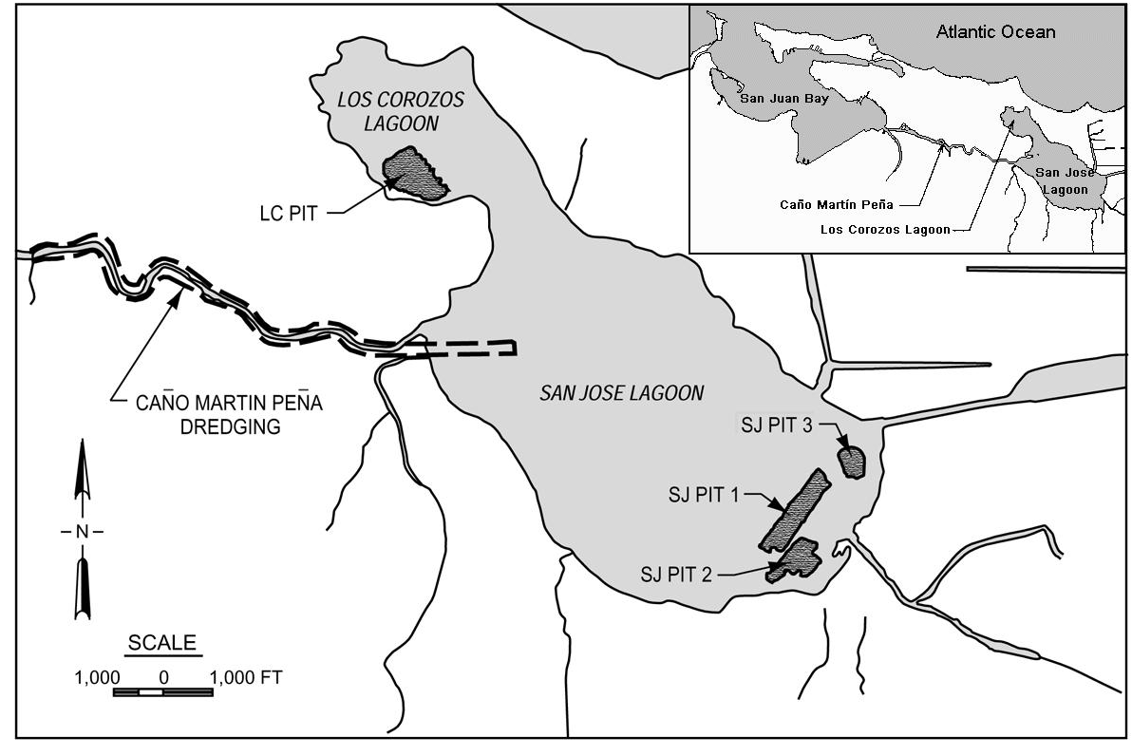
Figure 1: Existing Pits in San José and Los Corozos Lagoons

1.1 Objective

The objective of the study was to evaluate the adequacy of the cap designs to isolate contaminants of concern and, thus, satisfy water quality criteria.

1.2 Scope of Work

The scope of work consisted of four main components: sediment characterization for physical and geotechnical properties, consolidation analysis for pore water flux, chemical characterization, and contaminant flux analysis.

2. Methodologies

The long-term pore water flux from the three CAD sites due to consolidation following disposal of dredged material and capping was predicted using the Automated Dredging and Disposal Alternative Modeling System (ADDAMS) Primary Consolidation, Secondary Compression, and Desiccation of Dredged Fill (PSDDF) model (Schroeder and Palermo 1995 and Stark 1996). The CAD sites were assumed to have freely draining incompressible foundations. The consolidation properties are given in Figures 2 and 3.

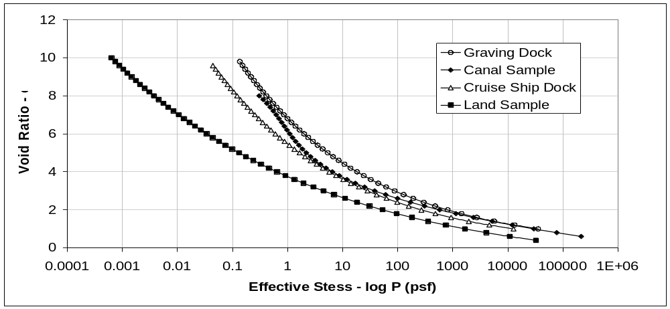
Figure 2: Void Ratio – Effective Stress Relationships

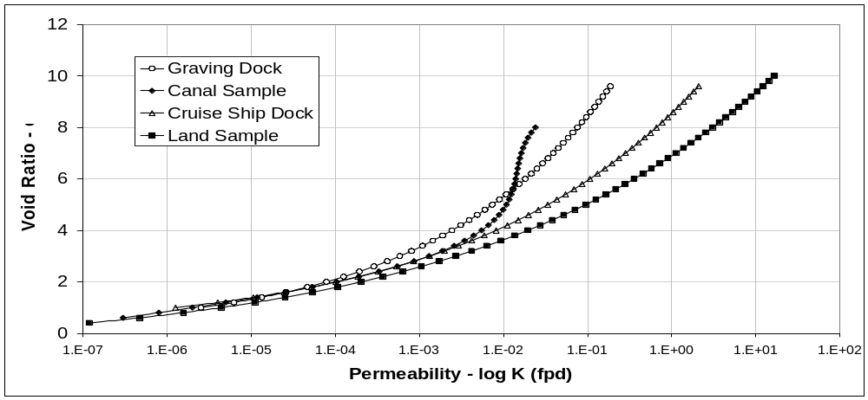
Figure 3: Void Ratio – Permeability Relationships

The USACE computer model, RECOVERY/CAP, is used to assess the long-term impact of capped, consolidating, contaminated bottom sediments or dredged materials placed in open water on surface waters (Ruiz and Schroeder 2002). The model couples contaminant interaction between the water column and the cap, between the cap and contaminated bottom sediment or dredged material, as well as between the contaminated and clean bottom materials. The contaminant is assumed to follow linear, reversible, equilibrium sorption and, if decay occurs, first-order decay kinetics. The sediment is uniform horizontally but segmented vertically into a well-mixed surface (active) layer and deep sediment. The deep sediment is segmented vertically into variably contaminated and clean sediment regions. Processes incorporated in the model are sorption, decay, volatilization, burial, resuspension, settling, bioturbation, and pore-water diffusion. The model was verified against laboratory and field data (Ruiz et al. 2001), as well as against an analytical solution for the water and mixed sediment layers.

The chemical characterizations of the materials were used to select the contaminants of concern and to assign initial conditions for the CAP modeling as given in Table 1.

Table 1: Initial Conditions for CAP Modeling of Capped Site
Parameter | Cap | Martin Peña Material |  | San Juan Material |  | Foundation
Parameter | Cap | Sediment | Fill | Cap | Sediment | Foundation
foc | 0.01 | 0.033 | 0.082 | 0.022 | 0.028 | 0.01
Selenium
Co, mg/kg | 0.01 | 1 | 1 | 1 | 1 | 0.01
Leachable Co, mg/kg | 0.005 | 0.5 | 0.5 | 0.5 | 0.5 | 0.5
Kd, L/kg | 3 | 3 | 3 | 3 | 3 | 3
DDE
Co, mg/kg | 0.0004 | 0.0379 | 0.0379 | 0.0004 | 0.0004 | 0.0004
Kow | 1x10⁷ | 1x10⁷ | 1x10⁷ | 1x10⁷ | 1x10⁷ | 1x10⁷
Kd, L/kg | 655 | 2162 | 5373 | 1441 | 1835 | 655
Dieldrin
Co, mg/kg | 0.00005 | 0.0203 | 0.0203 | 0.00005 | 0.00005 | 0.00005
Kow | 251000 | 251000 | 251000 | 251000 | 251000 | 251000
Kd, L/kg | 464 | 1531 | 3804 | 1021 | 1299 | 464

3. Results

The results for the San Juan sediment are shown in Figures 4 and 5. The release of copper is greatest initially, but it decreases rapidly, about 90% in two years. The quality of the capping material controls the initial release of copper. The water column concentration of copper is predicted to be below the Federal marine toxicity criteria (3.1 ug/L) at all times. The analysis shows the flux of copper from the dredged material is reduced by nearly a factor of 50 by the capping material. A similar reduction of flux could have been obtained using a 2-ft cap instead of the 4-ft cap employed in this study.

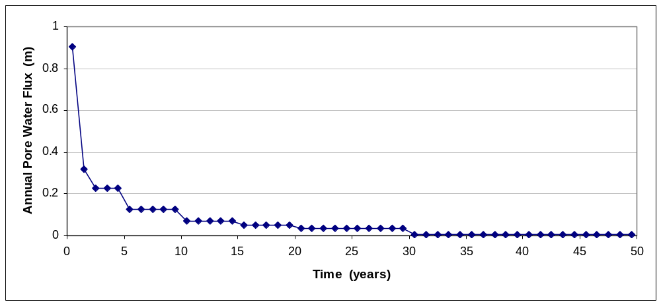
Figure 4: Annual Pore Water Flux from San Juan Material in Pit SJ 1 as a Function of Time

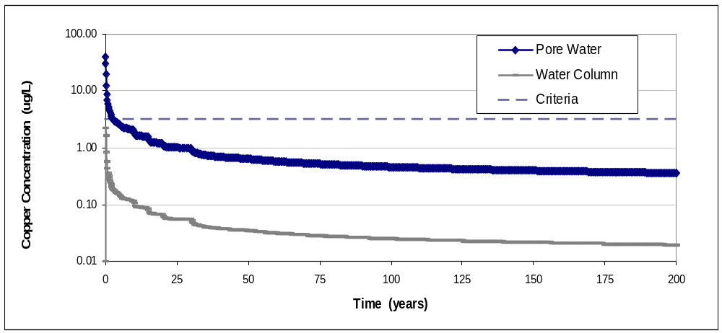
Figure 5: Copper Concentration from San Juan Material in Pit SJ 1 as a Function of Time

The concentrations of selenium in the pore water of the caps for the Martín Peña Canal material are shown in Figure 6. Selenium concentration will increase initially as pore water from the dredged material begins to pass into and through the cap, but then the concentration starts to decrease as the flux of pore water from the dredged material slows. After the flux of pore water ceases in about 5 years, the concentration continues to decrease because losses from interactions between the water column and surface sediments are faster than diffusion of selenium into the mixed layer from the dredged material. The contribution of selenium to the water column is predicted to be less than 1 percent of the water quality standard (71 ug/L). The maximum concentration of selenium in the mixed layer pore water is predicted to be less than 20 percent of the water quality standard. As such, it is clear that the cap provides ample protection for the water column.

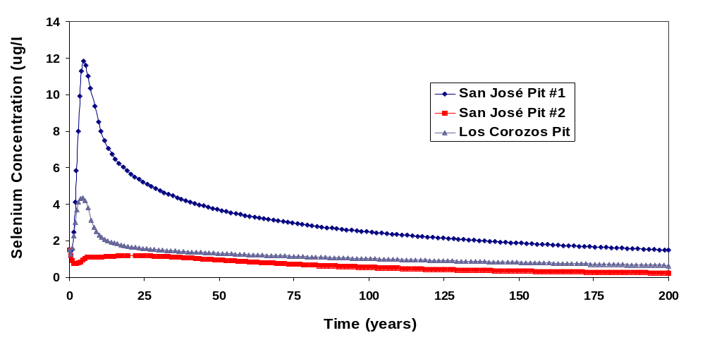Figure 6: Selenium Concentration in Pore Water of Martín Peña Material as a Function of Time

The results of the contaminant flux modeling for organics were trivial due to the strong hydrophobicity. The predicted concentration of organics in the water column and mixed layer remained unchanged throughout the simulations. During the period of active consolidation and pore water expulsion, organic contaminants moved only about 1 to 2 cm into the cap. Following consolidation, the movement of organics up from the dredged material is slower than the estimated rate of burial (deposition) at the site. The net movement of organics by diffusion considering retardation in the capping material is predicted to be less than 0.1 mm/yr while burial rates at the site are likely to be at 0.5 cm/yr.

4. Conclusions

The results show that the caps are highly effective in isolating the water column and aquatic organisms, except for very deep burrowing organisms (organisms that burrow deeper than the 0.6 meters of cap), from the contaminants of the dredged material. Burial of the cap by new deposition of suspended solids is predicted to occur at a faster rate than the diffusion of contaminants up into the cap after the initial period of rapid consolidation.

5. Acknowledgements

The results presented herein were obtained from research performed for the U.S. Army Corps of Engineers Jacksonville District by the U.S. Army Engineer Research and Development Center at the Waterways Experiment Station. Permission to publish this information was granted by the Chief of Engineers.

Company or University, Country, Academic Qualification, (Times Roman Font, Size 10pt)

Figures must be placed in the center of the page
Figures must centralized

6. References

Ruiz, C. E. and Schroeder, P. R. May 2002. "Evaluation of Contaminant Flux from CAD Sites Using the CAP Model," ASCE Dredging '02, Orlando, Florida.
Ruiz, C. E., Aziz, N. M., and Schroeder, P. R. 2001. "RECOVERY: A Contaminated Sediment-Water Interaction Model," Vol. 6, No. 3, Environmental Modeling & Assessment, Baltzer Science Publishers, pp. 151-158.
Schroeder, P.R. and Palermo, M.R. 1995. "The Automated Dredging and Disposal Alternatives Management System (ADDAMS)," Environmental Effects of Dredging Technical Notes EEDP-06-12, U.S. Army Engineer Waterways Experiment Station, Vicksburg, MS.
Stark, T.D. 1996. "Program Documentation and User's Guide: PSDDF Primary Consolidation, Secondary Compression, and Desiccation of Dredged Fill," Draft Instruction Report EL-96-XX, U.S. Army Engineer Waterways Experiment Station, Vicksburg, MS.
USACE – DNER. (2001). “Dredging of Caño Martín Peña Puerto Rico Draft Project Design Report and Environmental Impact Statement,” U.S. Army Corps of Engineers and Puerto Rico Department of Natural and Environmental Resources, March 2001.

