Second LACCEI International Latin American and Caribbean Conference for Engineering and Technology (LACCEI’2004)
“Challenges and Opportunities for Engineering Education, Research and Development”
2-4 June 2004, Miami, Florida, USA

Evaluation of Safety Aspects and Development of Guidelines to Identify Hazardous Intersections in Puerto Rico

Kathleen Díaz-Carrasquillo, EIT
Graduate Student, University of Puerto Rico, Mayagüez Campus, Mayagüez, Puerto Rico

Benjamín Colucci-Ríos, PhD, PE, PTOE
Professor, University of Puerto Rico, Mayagüez Campus, Mayagüez, Puerto Rico

Julio Quintana-Díaz, PhD
Professor, University of Puerto Rico, Mayagüez Campus, Mayagüez, Puerto Rico

Felipe Luyanda-Villafañe, DE, PE
Professor, University of Puerto Rico, Mayagüez Campus, Mayagüez, Puerto Rico

Abstract:

In the United States (year 2000), 2.8 million accidents were associated with intersections, representing approximately 44% of all accidents and an estimated societal cost of $40 billions. The principal objective of this research is to explore alternatives to develop an analytical procedure that can be adjusted to the needs and availability of accident data in Puerto Rico to identify hazardous intersections. The study area was reduced to seventeen (17) municipalities on the western region of Puerto Rico which are representatives of the island. An adaptation to the methodology developed by the Iowa Department of Transportation was performed to identify hazardous intersections. A reconnaissance survey combined with a visual inspection was then performed on the intersection that were identified as hazardous in the preliminary analysis to assess the safety related issues associated with these sites. The intersections that were evaluated and classified as hazardous were asymmetric and/or complex in terms of geometry. The potential candidates of hazardous intersections had the following characteristics: intersections with a combination of approach access with a significant grade; skewed angle or uneven topography; uneven flow and/or lanes in the principal arterial versus secondary routes; presence of frontage roads with businesses; presence of pedestrians and commercial access in the vicinity of the intersection. Based on the findings, several countermeasures were recommended for the identified safety problems. Mainly these recommendations were directed to the access control regulation, the focus of engineering, enforcement, education and emergency response decisions to the population affected, law enforcement directed to the located problems identified, and the more rigorous consideration of Puerto Rico peculiarities in future projects or improvements. Other recommendations in terms of guidelines to identify hazardous locations were focused to agencies that deal with the collection and analysis of intersections safety and accident data, such as the Highway and Transportation Authority of Puerto Rico, the Accident Analysis Office of the Department of Public Works, Traffic Safety Commission and the Puerto Rico Police Department, among others.

Keywords
Intersection, Safety, Ranking, Accidents, Crashes

- Introduction

Intersections are one of the most complex elements studied within the highways transportation system due to the conflicts they generate between motor vehicles, pedestrians and cyclists. This complexity generates more traffic crashes in comparison with other geometric features such as rural segments. For this reason, intersections should be thoroughly studied deeply to assure their optimal operation without sacrificing safety.

  - Objectives

The main objective of this study is to identify dangerous intersections in Puerto Rico and the possible countermeasures to minimize their hazardous potential. The frequency, severity, accident rate by quantity of vehicles entering at the facility and the benefit/cost ratio were evaluated. In addition, site visits were conducted to verify and to observe if other circumstances exist that were not clearly stated by the statistical analysis in the accident database and could be contributing to the accidents that occurs in the vicinity of the intersections.

  - Study Area

The study area comprises seventeen (17) municipalities located in the western region of Puerto Rico (see Figure 1). This area is representative of the island of Puerto Rico because it contains the main highways in the road network such as the PR-2, PR-100, PR-111, and PR-115. The west area has a diversity of characteristics that can be observed around the entire Island; this in relation to its topography, climate, population, and zone, among others.

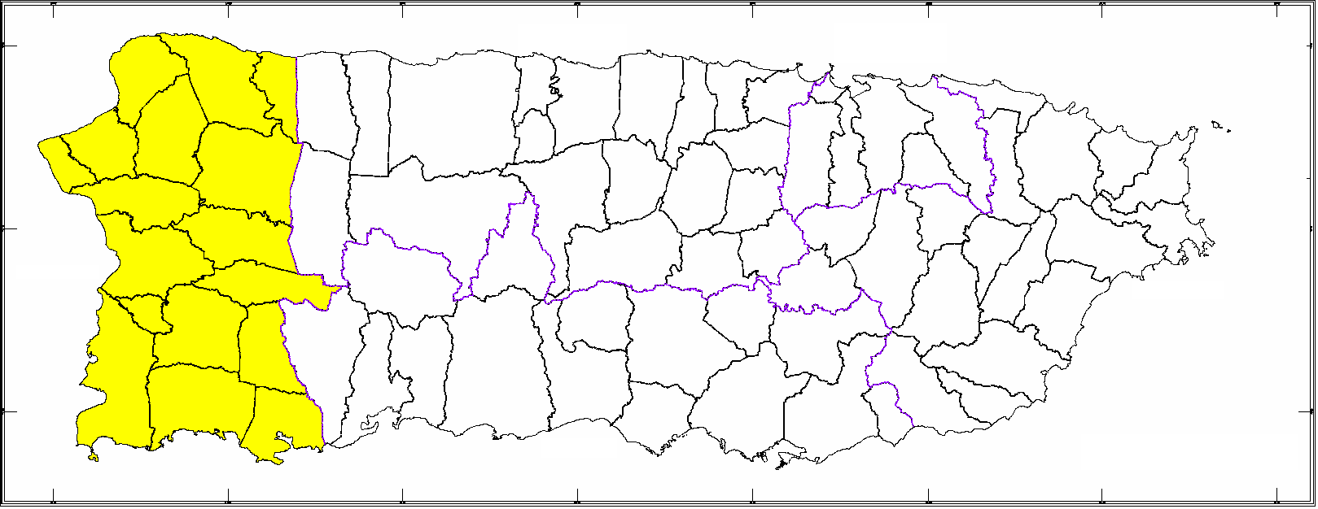
1
2
3
4
5
6
7
8
9
10
11
12
13
14
15
16
17
N
ID | Municipalities | ID | Municipalities
1 | Mayagüez | 10 | Quebradillas
2 | Aguadilla | 11 | Sabana Grande
3 | San Sebastián | 12 | Lajas
4 | Isabela | 13 | Hormigueros
5 | Aguada | 14 | Guánica
6 | Moca | 15 | Rincón
7 | San Germán | 16 | Las Marías
8 | Cabo Rojo | 17 | Maricao
9 | Añasco
Figure 1: Study Area Map and Puerto Rico Municipalities Evaluated in Study

- Literature Review

The literature review for this investigation was focused in three main aspects associated to the countermeasures used to improve intersection safety, different data and information sources in the United States, Puerto Rico, and Latin America, and techniques used to identify hazardous intersections and the contributing factors evaluated. A brief explanation of the relevant information for this research is presented forward.

  - Techniques to Identify Hazardous Intersections

Garbel and Hoel (2001), discussed several methods that were used to analyze accidents in segments and intersections. For example, the method of accident frequency summarizes the number of accidents by location. This is a simple method because additional information is not required, but has the disadvantage that does not consider the level of exposure, severity, nor segments length. It can be applied initially in order to obtain an initial screening of the data follow by other type of analysis. The method of accidents rate at intersections is function of the quantity of accidents and the average daily traffic volume that enters to an intersection. For example, to determine the rate per each million entering vehicles (RMEV) when analyzing intersections, the following formula is used:

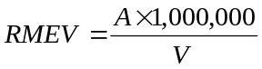 (1)

Where:
A = total number of accidents per year in the studied place
V = average yearly traffic entering at intersection (AVEI x 365 = (ADT1 + ADT2) x 365)

This method gives priority to locations with high frequency of accidents in relation to volume; nevertheless it tends to give priority to locations with few accidents and low volume.

The combination of different methods of accidents analysis decreases their deficiencies. For example, the rate-frequency method is a combination of the accidents rate method and the frequency method. The steps include a frequency ranking to identify the intersections with higher frequency followed by a ranking of accident rate. The results of combining these methods reduce their deficiencies; however the severity of accidents is not being considered.

The accidents severity method uses monetary losses according to the severity level implied by the crash event. It assigns weights to the different accidents categories classified as fatality, injury and property damage only. This method helps to identify places with serious accidents and fatalities; nevertheless, places with a single fatality have more weight than places with many property damage only accidents.

  - Recent Studies Related to Intersection Safety

Oh et al. (2004), developed prediction models of accidents in rural intersections. The results obtained are based on the analysis of variables such as: vehicular flow, commercial routes, percent of trucks, vertical alignments, accesses angle, horizontal alignment, speed, presence of median, maneuvers (turns), braking distance, and illumination.

Hill and Lindly (2004) developed models that predict the amount of violations per hour of users who do not respect the red light (red-light-running). The variables identified in the study as the best indicators were the Average Daily Traffic (ADT), number of lanes, speed in the major street and the crossing street, and the distance to the following intersection and the previous one.
Schattler and Datta (2004), studied the behavior of drivers at urban intersections. They have related 28% of accidents to violations associated to red-light running and 40% of the fatalities and serious injured. The improvements to consider for these cases: are redesign the yellow interval and all-red of traffic light phases, increase the lights size, and to verify the alignment on the corresponding access.

Zimmerman and Bonneson (2004), studied a potential countermeasure for the intersections safety on high speed traffic lights. They studied how to reduce the amount of vehicles in the dilemma zone of an intersection. The dilemma zone (Figure 2) is defined as the area where 90 % to 10% of the vehicles pass the intersection when lights change to yellow.

Figure 2: Illustration of the Intersection Dilemma Zone
90% stops and 10% go ahead
10% stops and 90% go ahead
Change of green to yellow light

- Methodology

The methodology followed in this research is depicted in Figure 3.
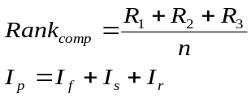
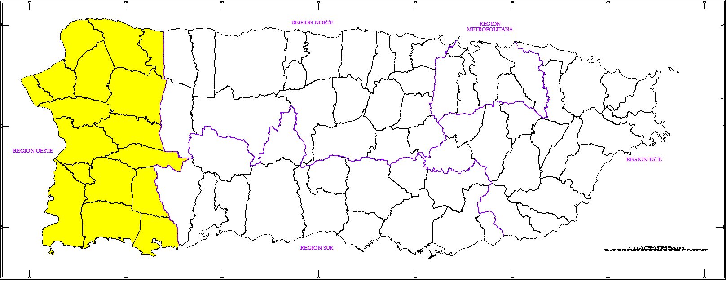
Literature Review
Data Analysis Methods
Statistical Methods
Intersections Design
Commercial Programs
Countermeasures
Others
Data Compilation
Police Department of Puerto Rico
Traffic Safety Commission
Accidents Analysis Office
NHTSA/FARS
Others
Statistical Analysis
Descriptive
Cross tabs
Box plot
Intersections Selection
R1 - frequency
R2 - severity
R3 - accident rate

Field Visits
Map localization
Problems Identification
Contributing Factors
Calibration and verification
Data Filter
Data bases comparison
Interviews
N
Puerto Rico
Study area
Conclusions and Recommendations
Statistical Analyses Results
Findings
Possible Countermeasures
Guidelines
Figure 3: Methodology Flowchart

The literature review was followed by the data collection of the main accident databases in Puerto Rico and the United States followed by statistical analysis to identify trends and relationships; ranking development for the intersection selection; field inspections; calibration, validation and verification; and the conclusions and recommendations.

  - Ranking Methodology

The Iowa Transportation Department (Office of Traffic Safety, 2002) developed a ranking system of localities with high accident levels where is combined the different techniques to analyze segments or localities (intersections). Data like accidents frequency, average daily traffic, segment length, and accidents severity were used. This technique began with a preliminary filter. Then, they were classified individually in three categories: frequency, accident rate, and severity. To calculate a severity level a 400 weight was assigned to a fatality, 60 to a major injury, 4 to a minor injury and 1 to property damage only. The frequencies of the categories by intersections or segments were sorted individually in descending order and the values were added in other to determine the final ranking.

An adaptation to this methodology was made to identify hazardous intersections. The analysis began reducing the amount of data to be analyzed. An initial ranking was performed to select the one hundred (100) intersections with higher accidents frequency. Then an individual ranking is made for frequency, accidents rate, and severity.

Another ranking based on three indexes was made to calculate a hazardous index that mathematically can be added because the calculated values are dimensionless. In addition, the individual value of each intersection can be understood like the times that this value moves away from the average of the one hundred (100) intersections in the different categories. The equations used are presented as follows (see Equation 2 and 3).

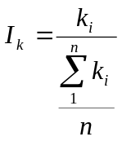 (2)
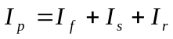 (3)
Where:
I_{k} = frequency (I_{f}), severity (I_{s}) or accident rate (I_{r}) index
k_{i} = corresponding value to the index that is calculating as frequency, severity or accident rate
n = fix sample size, in this case 100 intersections
I_{p} = hazardous index

From these results, box plots were developed to identify the hazardous intersections (in the group of 100) to that ones between the third quartile of the distribution and the maximum index, or the outliers.

- Data Analysis Results

  - Preliminary Trends

The main results obtained from the descriptive statistical analysis in the study area are the followings:
- 39.1% of accidents at intersections had no control
- 31.5% of accidents at intersections occurred in commercial zone
- 73.6% of accidents at intersections occurred in the urban area
- 73.2% of fatalities at intersections were men
- 22% of fatalities at intersections corresponded to non-occupants
- 15.9% of fatalities at intersections occurred in the month of December followed by April with 12.2%
- 29.3% of fatalities at intersections were found with blood alcohol content
- 37.5% of fatalities at intersections with blood alcohol content corresponded to the age range between 40 to 49 years
- 25% of fatalities at intersections with blood alcohol content occurred on April
- 33.3% of fatalities associated to pedestrians at intersections were blood alcohol content
- The higher percent of accidents at intersections (22.1%) occurred in the range of 3:00 – 6:00 PM
- The higher percent of accidents at intersections (17.3%) occurred on Fridays
- 34.2% of accidents at intersections of two state highways occurred entering in angle at the intersection

  - Ranking

The selected intersections were ranked as follow. The first twenty (20) hazardous intersections were located by areas. For example, eight (8) intersections in the municipality of Mayagüez and five (5) in Moca and San Sebastián were observed. Between the first twenty identified intersections, fourteen (14) were located in the PR-2 where a high volume of vehicles was observed and four (4) in the PR-111. In addition, several extremes and outliers intersections in different categories were observed. When the index was added, an intersection was observed as an extreme, which corresponds to the intersection of the PR-2 and the PR-343. This index was 2.95 and is interpreted as a 195% greater than the average value of the one hundred (100) intersections. Table 1 illustrates the intersections that are between the maximum value and the third quartile in the categories of frequency, severity, accident rate, and hazardous index that is determined adding the three individual indexes. The shaded cells correspond to the outliers. Figure 4 shows the corresponding box plot of the hazardous index.

Table 1: Intersections between the Maximum and 3rd Quartile

Frequency | Severity | Accident Rate | Hazardous Index
PR-2 and PR-343 | PR-2 and PR-485 | PR-110 and PR-125 | PR-2 and PR-343
PR-2 and PR-107 | PR-2 and PR-343 | PR-2 and PR-343 | PR-2 and PR-107
PR-2 and PR-114 | PR-2 and PR-103 | PR-111 and PR-445 | PR-2 and PR-402
PR-2 and PR-199 | PR-111 and PR-446 | PR-110 and PR-111 | PR-2 and PR-199
PR-2 and PR-402 | PR-2 and PR-329 | PR-2 and PR-402 | PR-110 and PR-111
PR-2 and PR-186 | PR-2 and PR-199 | PR-111 and PR-446 | PR-111 and PR-446
PR-110 and PR-111 | PR-2 and PR-402 | PR-65 and PR-108 | PR-110 and PR-125
PR-2 and PR-725 | PR-2 and PR-394 | PR-111 and PR-119 | PR-111 and PR-445
PR-2 and PR-112 | PR-2 and PR-446 | PR-370 and PR-650 | PR-2 and PR-114
PR-2 and PR-233 | PR-2 and PR-474 | PR-2 and PR-107 | PR-2 and PR-485
PR-111 and PR-445 | PR-2 and PR-186 | PR-116 and PR-117 | PR-2 and PR-186
PR-2 and PR-417 | PR-2 and PR-725 | PR-111 and PR-420 | PR-2 and PR-474
PR-2 and PR-459 | PR-2 and PR-114 | PR-2 and PR-112 | PR-2 and PR-725
PR-65 and PR-108 | PR-110 and PR-111 | PR-370 and PR-725 | PR-2 and PR-329
PR-2 and PR-474 | PR-111 and PR-420 | PR-105 and PR-653 | PR-111 and PR-420
PR-2 and PR-329 | PR-111 and PR-445 | PR-102 and PR-103 | PR-2 and PR-112
PR-2 and PR-122 | PR-100 and PR-102 | PR-2 and PR-474 | PR-65 and PR-108
PR-111 and PR-420 | PR-116 and PR-117 | PR-109 and PR-125 | PR-2 and PR-103
PR-111 and PR-446 | PR-2 and PR-107 | PR-2 and PR-417 | PR-2 and PR-417
PR-110 and PR-125 | PR-2 and PR-63 | PR-115 and PR-411 | PR-2 and PR-394
PR-111 and PR-444 | PR-2 and PR-319 | PR-111 and PR-444 | PR-100 and PR-102
PR-100 and PR-102 | PR-107 and PR-467 | PR-101 and PR-301 | PR-2 and PR-233
PR-2 and PR-394 | PR-125 and PR-446 | PR-349 and PR-790 | PR-2 and PR-446
PR-2 and PR-111 | PR-2 and PR-330 | PR-650 and PR-714 | PR-116 and PR-117
PR-2 and PR-119 | PR-2 and PR-417 | PR-116 and PR-332 | PR-111 and PR-444

When the field inspections were made the situation in many of the identified intersections was observed. In general, most of the studied intersections were asymmetric in its geometry, quantity of lanes, vertical and horizontal alignment, among others. Intersections are located mainly in commercial areas or surrounded by isolated businesses like restaurants of fast food, pharmacies, factories, gas stations, among others. In addition, they were dense spaced of each others.

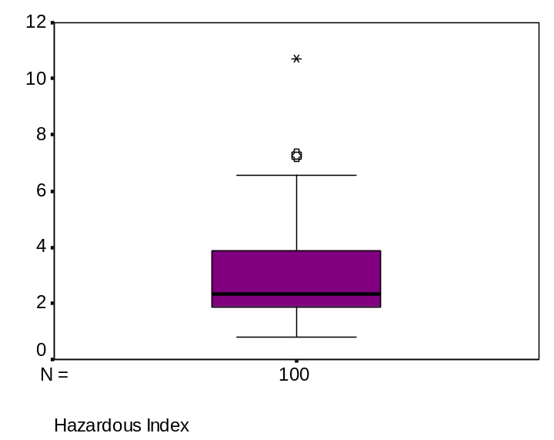
PR-2 and PR-343

Figure 4: Box Plot of the Hazardous Index

- Conclusions and Recommendations

The followings are the conclusions and recommendations:
- Regulate control access and make traffic studies to evaluate the impacts of the developments.
- Evaluate the problems rural and urban areas separately
- Law enforcement by placing video-cameras at the intersections to control user’s behavior.
- Consider Puerto Rico peculiarities in future projects like:
- Excess of asymmetric intersections
- Possible presence of polished aggregate in concrete pavement
- Large extensions of urbanized areas with irregular topography
- Improve the accurate and acceleration of data entry, compilation, and analysis by:
- New technology like global positioning system and the development of a unique system identification to identify highways that are not state highways or access to relevant places like universities or commerce.
- The police must be trained on suitable form so they can identify correctly the terminology used in the police report.
- Periodical analysis to identify hazardous intersections in order to give priorities for new projects.

- References

Jutaek Oh, Simon Washington y Keechoo Choi (2004), “Development of Accident Prediction Models for Rural Highway Intersections”, TRB 2004
Karl Zimmerman y James A. Bonneson (2004), “Number of Vehicles in the Dilemma Zone as a Potential Measure of Intersection Safety at High-Speed Signalized Intersections”, TRB 2004
Kerrie L. Schattler y Tapan K. Datta, (2004) “Driver Behavior Characteristics at Urban Signalized Intersections”, TRB 2004
Nicholas J. Garber, Lester A. Hoel (2001), “Traffic and Highway Engineering”, 3rd Edition, 5th and 7th Chapter
Office of Traffic and Safety, Iowa Department of Transportation, (2002) “Evaluation of the Iowa DOT’s Safety Improvement Candidate List Process”, CTRE Project 00-74
Stephen E. Hill y Jay K. Lindly (2004), “Red Light Running Prediction and Analysis”, TRB-2004

