Second LACCEI International Latin American and Caribbean Conference for Engineering and Technology (LACCEI’2004)
“Challenges and Opportunities for Engineering Education, Research and Development”
2-4 June 2004, Miami, Florida, USA

Additional Data Security with Dynamic Steganography

Subbarao V. Wunnava, PhD

Professor, Florida International University, Miami, Fl., USA

Richard P. Zavaleta, MSEE

Research Associate, Florida International University, Miami, Fl., USA

Abstract
Today's data is protected by many layers of security. Data activity may be hidden, in addition to encryption, to make it more secure. Steganography provides a possible solution, hiding the data by embedding it into another data, to further enhance the data security. This paper introduce the concept of steganography and further improvements, such as dynamic adaptation as well as the attacks on steganography

Keywords
Steganography, Security.

1. Introduction

Encryption is a common tool for securing the data. It protects the data by scrambling it. See Fig. 1a. Steganography, on the other hand, hides the data by embedding it into another data in such a way that it does not shows signs of carrying the hidden file. Fig. 1b is hiding a text data in it and it does not show it.

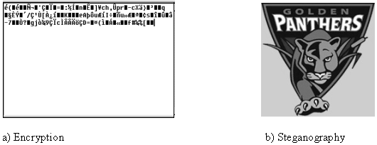

Figure 1: Encryption and steganography

The file that hides the information is called cover and the information itself is called message. The cover with the embedded message is called stego-signal. A simplified block diagram is shown in Fig. 2.

Classic steganography is usually interested only in recovering the information and the cover is used just to carry it. This cover should be a file whose transmission does not raise suspicion. There is a particular case of steganography where both the cover and the hidden information are important. That is the case when embedding information that acts as the author’s signature protects a digital property. This is usually case watermarking.
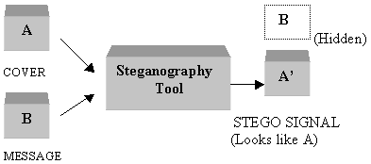

Figure 2: Steganography block diagram

2. Least Significant Bit Steganography

This method uses the least significant bits (LSB) of the bytes of the cover to hide the message. A computer’s file is made out of ones and zeros, called bits. A byte is a group of bits. Every type of file has a different format. For example, a bmp file is shown in Fig. 3a

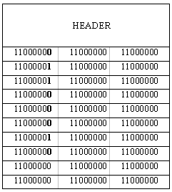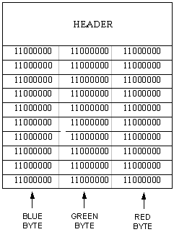
(a) (b)

Figure 3: Example of bmp and embedding into bmp file

The bmp file contains video information. A video image consists of pixels, which are represented by three bytes in a bmp file. There is a byte for the amount of blue color; another byte represents the green and the other the red. The value of the byte represents the hue of the color. In the example of Fig. 3a, the data represents 10 identical pixels, and the value of each of the three-color byte of the pixel is also the same, meaning that the pixels look like gray, and the picture is a uniform image of gray.

Since a color is represented by 8 bits, there is 2⁸ hues of the color, from 0000 0000 to 1111 1111. Steganography takes advantage of the fact that the human eye cannot distinguish two close values of the same color. For example blue 1100 0000 = 192 is not the same as blue 1100 0001 = 193, but the human eyes cannot distinguish the difference. Moreover, all LSBs of all bytes of a bmp image could be change and the image still would look the same to an observer. Then a message could be embedded in the LSBs of a bmp image, which would carry it without rising suspicion.
The hiding of a letter b would require 8 bits because, according to ASCCII code the byte 0110 0010 represents the letter b, and it can be embedded into our bmp example, as shown in Fig. 3b. After being embedded these bits can be recuperated and assembled together to obtain the letter b again.

3. Steganography Capacity

Every change made in the cover increases the probability of suspicion on the stego-signal. The alteration done by the message in the cover has to be minimized. Changing LSBs produces the minimum alteration. However, even if all LSBs were used for message embedding that would represent one bit on every cover byte. In other words one bit out of eight would be useful. In this case the maximum message size that could be embedded is 1/8 the size of the cover.

The number of bits useful for steganography depends on the type of the file. There are bytes that even its LSB cannot be used for embedding. For example, the letter a is represented by 0110 0010. A change of its LSB would be 0110 0011 which represents the letter c.

4.Modern Steganography

Modern steganography does not relay in sequential LSB embedding like in the above example. In case a file has raised suspicion and is being analyzed to recover the message, the embedding must have extra protection. Pseudorandom embedding and encryption protects the integrity of the data. The message can be encrypted before embedding, controlled by a key like AES [1], and instead of being embedded sequentially it can be pseudo randomly embedded. The sequence can be controlled by a password. See Fig. 4

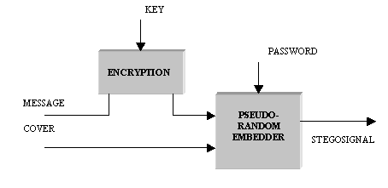

Figure 4: Steganography with pseudorandom embedding and encryption

5.Attacks on Steganography

Although pseudorandom embedding and encryption add security in case the file is under analysis, the main purpose of steganography is not raise suspicion to begin with, even when is being analyzed.

Embedding information in multimedia files is virtually undetected for the human eye or ear. However, the hidden information can be detected with the use of computers [2] [3].

One of the ways to analyze a file to find out if there is a hidden message is called visual attack. This method transforms the image to full color, 1111 1111, or no color, 0000 0000, according to the byte’s LSB. That is, it changes the byte to 0000 0000 if the LSB is 0, and 1111 1111 if the LSB is 1. Fig. 5 is an example of this analysis on the example given on Fig. 3b.
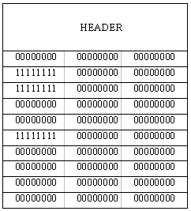

Figure 5: Visual Attack on Fig. 3b

In order to visualize the results, the image of Fig. 5a, which does not have any hidden file, is subject to the visual attack. The result is illustrated on Fig. 5b. Then a file is embedded having Fig. 5a as a cover, resulting Fig. 5c. The result of the attack on this stego-signal is illustrated on Fig. 5d.

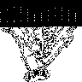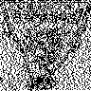
(a) (b) (c) (d) (e) (f)

Figure 6: Visual Attack on Fig. 3b

6.Dynamic Steganography

Visual attack can detect easily sequential embedding on the LSBs, as shown in Fig. 5d. It shows a black segment where the message is embedded. This happens because insertion was done sequentially, without taking care of the cover characteristics. Fig. 5e is the stego-signal with pseudo randomly embedding spread all over the cover. That’s why an attack on this stego-signal shows does not show the black segment, but it is still suspicious. See Fig. 5f.

If the LSBs of consecutive bytes of the cover were 11111111 the visual attack would show a white portion. By embedding in this region a visual attack would show it as black points. That would raise suspicion. But if the original sequence had been 0000011111, with a transition in the middle, embedding in the middle would not be as noticeable.

If the insertion takes into account the characteristic of the cover, then the insertion would dynamically adapt to the cover being used. That would mean less change in the cover and less probability to raise suspicion.

A dynamic steganography example was performed with the following algorithm. When looking at the LSBs of the cover, if there is a transition, 1 to 0 or 0 to 1, the next bit is chosen for embedding. Then continue searching for next transition. See Fig. 6.

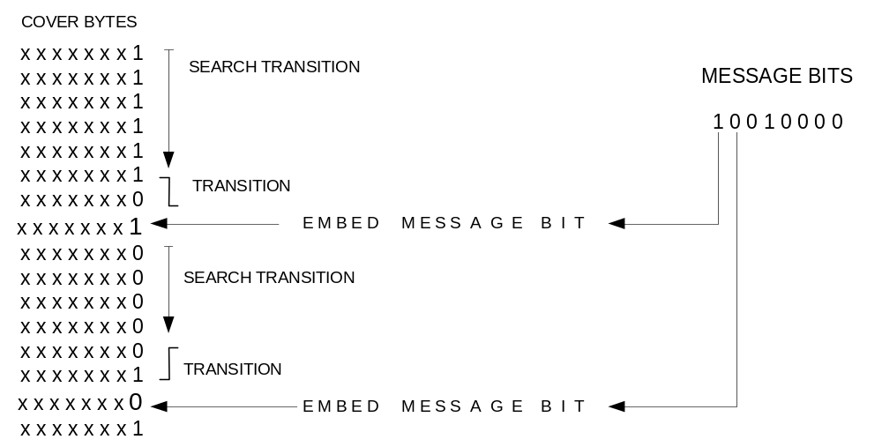

Figure 6: Dynamic steganography example

The stego-signal using this technique is shown in Fig. 7d. It was possible to embed a third of the original message. A visual attack on this stego-signal is shown in Fig. 7e. It is similar to Fig. 7a, which is an analysis of the cover without any message. So the detection would be harder.

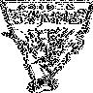
(a) (b) (c) (d) (e)

Figure 7: Dynamic Steganography versus other techniques

7. Conclusions

Dynamic Steganography increments the protection of the data by adapting the embedding according with the characteristic of the cover being used. The price to pay is a reduction of the hiding capacity. Steganography is well suited for short messages. Video files could be used as a cover for larger messages.

8. References

National Institute of Standards and Technology, “Specifications for the Advanced Encryption Standard (AES)”, Federal Information Processing Standards Publication 197.
Neil F. Johnson, Sushil Jajodia. “Exploring Steganography: Seeing the Unseen”, IEEE. Computer, February 1998, Vol. 31. No. 2, pp. 26-34.
Niels Provos, Peter Honeyman, “Detecting Steganographic Content on the Internet”. Network and Distributed System Security Symposium, San Diego, CA, February 2002, pp. 2-13.

